INTRODUCTION TO CYBERSECURITY
LEARNER GUIDE

Module Code | 252901001-KM-01,
NQF Level | 4
Credits | 8
Curriculum Code | 252901001
Qualification Title | Occupational Certificate: Cybersecurity Analyst
SAQA QUAL ID | 118986

Name
Contact Address
Telephone (H)
Telephone (W)
Facsimile
Cellular
E-mail

Note to the learner
This Learner Guide provides a comprehensive overview of the module. It is designed to improve the skills and knowledge of learners, and thus enabling them to effectively and efficiently complete specific tasks.
Entry Requirements

- NQF 4
Provider Accreditation Requirements for the Knowledge Module

Physical Requirements
- The provider must have lesson plans and structured learning material or provide learners with access to structured learning material that addresses all the topics in all the knowledge modules as well as the applied knowledge in the practical skills.
- QCTO/ MICT SETA requirements

Human Resource Requirements:
- Lecturer/learner ratio of 1:20 (Maximum)
- Qualification of lecturer (SME):
    - NQF 6 in industry recognised qualifications with 1 years’ experience in the IT industry
    - CYBERSECURITY vendor certification
- Assessors and moderators: accredited by the MICT SETA
Legal Requirements
- Legal (product) licences to use the software for learning and training
- OHS compliance certificate
- Ethical clearance (where necessary)
Module Purpose
The main focus of the learning in this knowledge module is to build an understanding of fundamentals of various computer and network security threats such as identity theft, credit card fraud, phishing, virus and backdoors, emails hoaxes, loss of confidential information, hacking attacks, and social engineering

Topic elements to be covered include
The learning will enable learners to demonstrate an understanding of:
- KM-01-KT01: Introduction to computer and mobile device security
- KM-01-KT02: Various computer and network security threats
- KM-01-KT03: Identity theft
- KM-01-KT04: Adopting good cybersecurity practices
- KM-01-KT05: Safeguard mobile, media and social networking profiles as user
- KM-01-KT06: Protecting computers, accounts and data as user
- KM-01-KT07: Understand security incidents and reporting

Venue, Date and Time:
Consult your facilitator should there be any changes to the venue, date and/or time.
Refer to your timetable
Assessments

The only way to establish whether you are competent and have accomplished the learning outcomes is through continuous assessments. This assessment process involves interpreting evidence about your ability to perform certain tasks. You will be required to perform certain procedures and tasks during the training programmer and will be assessed on them to certify your competence.

This module includes assessments in the form of self-evaluations/activities and exercises. The exercises, activities and self-assessments will be done in pairs, groups or on your own. These exercises/activities or self-assessments (Learner workbook) must be handed to the facilitator. It will be added to your portfolio of evidence, which will be proof signed by your facilitator that you have successfully performed these tasks.

Listen carefully to the instructions of the facilitator and do the given activities in the time given to you.

KM-01-KT01: Introduction to computer and mobile device security
Topic elements to be covered include:
- KT0101 Governance and legislation
- KT0102 Security policy
- KT0103 Physical security (e.g. biometric authentication
- KT0104 Web content filters
- KT0105 Need for protection of privacy and data

KT0101 Governance and legislation

What is mobile security device?
Mobile Device Security refers to the measures designed to protect sensitive information stored on and transmitted by laptops, smartphones, tablets, wearables, and other portable devices. At the root of mobile device security is the goal of keeping unauthorized users from accessing the enterprise network.
Why is Mobile Device Security important?
With more than half of business PCs now mobile, portable devices present distinct challenges to network security, which must account for all of the locations and uses that employees require of the company network. Potential threats to devices include malicious mobile apps, phishing scams, data leakage, spyware, and unsecure Wi-Fi networks. On top of that, enterprises have to account for the possibility of an employee losing a mobile device or the device being stolen. To avoid a security breach, companies should take clear, preventative steps to reduce the risk.

What are the benefits of Mobile Device Security?
Mobile device security, or mobile device management, provides the following:

- Regulatory compliance
- Security policy enforcement
- Support of “bring your own device” (BYOD)
- Remote control of device updates
- Application control
- Automated device registration
- Data backup
Above all, mobile device security protects an enterprise from unknown or malicious outsiders being able to access sensitive company data.

How does Mobile Device Security work?
Securing mobile devices requires a multi-layered approach and investment in enterprise solutions. While there are key elements to mobile device security, each organization needs to find what best fits its network.

To get started, here are some mobile security best practices:

Establish, share, and enforce clear policies and processes
Mobile device rules are only as effective as a company’s ability to properly communicate those policies to employees. Mobile device security should include clear rules about:
- What devices can be used
- Allowed OS levels
- What the company can and cannot access on a personal phone
- Whether IT can remote wipe a device
- Password requirements and frequency for updating passwords

Password protection
One of the most basic ways to prevent unauthorized access to a mobile device is to create a strong password, and yet weak passwords are still a persistent problem that contributes to the majority of data hacks. Another common security problem is workers using the same password for their mobile device, email, and every work-related account. It is critical that employees create strong, unique passwords (of at least eight characters) and create different passwords for different accounts.

Leverage biometrics
Instead of relying on traditional methods of mobile access security, such as passwords, some companies are looking to biometrics as a safer alternative. Biometric authentication is when a computer uses measurable biological characteristics, such as face, fingerprint, voice, or iris recognition for identification and access. Multiple biometric authentication methods are now available on smartphones and are easy for workers to set up and use.

Avoid public Wi-Fi
A mobile device is only as secure as the network through which it transmits data. Companies need to educate employees about the dangers of using public Wi-Fi networks, which are vulnerable to attacks from hackers who can easily breach a device, access the network, and steal data. The best defense is to encourage smart user behavior and prohibit the use of open Wi-Fi networks, no matter the convenience.

Beware of apps
Malicious apps are some of the fastest growing threats to mobile devices. When an employee unknowingly downloads one, either for work or personal reasons, it provides unauthorized access to the company’s network and data. To combat this rising threat, companies have two options: instruct employees about the dangers of downloading unapproved apps, or ban employees from downloading certain apps on their phones altogether.

Mobile device encryption:
Most mobile devices are bundled with a built-in encryption feature. Users need to locate this feature on their device and enter a password to encrypt their device. With this method, data is converted into a code that can only be accessed by authorized users. This is important in case of theft, and it prevents unauthorized access.

What are the different types of Mobile Device Security?
There are many aspects to a complete security plan. Common elements of a mobile security solution include the following:

- Enterprise Mobile Management platform: In addition to setting up internal device policies that protect against unauthorized access, it’s equally important to have an Enterprise Mobile Management (EMM) platform that enables IT to gather real-time insights to catch potential threats.
- Email security: Email is the most popular way for hackers to spread ransomware and other malware. To combat such attacks, it’s critical for businesses to be armed with advanced email security that can detect, block, and address threats faster; prevent any data loss; and protect important information in transit with end-to-end encryption.
- Endpoint protection: This approach protects enterprise networks that are remotely accessed by mobile devices. Endpoint security protects companies by ensuring that portable devices follow security standards and by quickly alerting security teams of detected threats before they can do damage. Endpoint protection also allows IT administrators to monitor operation functions and data backup strategies.
- VPN: A virtual private network, or VPN, extends a private network across a public network. This enables users to send and receive data across shared or public networks as if their computing devices were directly connected to the private network. VPNs’ encryption technology allows remote users and branch offices to securely access corporate applications and resources.
- Secure web gateway: A secure web gateway protects against online security threats by enforcing company security policies and defending against phishing and malware in real-time. This is especially important for cloud security as this type of protection can identify an attack on one location and immediately stop it at other branches.
- Cloud access security broker: A cloud access security broker (CASB) is a tool that sits between cloud service consumers and cloud service providers to enforce security, compliance, and governance policies for cloud applications. CASBs help organizations extend the security controls of their on-premises infrastructure to the cloud.

Cybersecurity is a growing concern for governments, with the push for universal access to the Internet, the increasing ubiquity of social networks and the growing reliance on digital government service, and given a growing range of threats from foreign powers, terrorists and criminals. These complex issues span all government ministries, their agencies and contractors, plus provincial and municipal government, and require the state to create legal frameworks and agencies to protect data and offer advice to businesses and citizens, plus ensuring a sufficient supply of skilled technicians and engineers. In the case of South Africa, its government responded in 2015 with a National Cybersecurity Policy Framework (NCPF), with implementation led by the Ministry of State Security. The Protection of Personal Information (POPI) Act of 2013 created the Information Regulator to ensure data privacy. The POPI regime is only being implemented slowly and has overly wide exemptions for national security. South Africa lags behind advanced economies in cybersecurity legislation, in government coordination, in engagement with business and citizens, and in the supply of skilled labour. Delays have meant it lacks the experiences obtained in faster moving countries, and the improvements they have made to their policies and, especially, implementation. Parliament has neither pressed the government for faster action nor explored areas where powers might have been taken that infringe human rights.

National governments are adopting cybersecurity strategies to address a wide range of threats (OECD, 2012), including foreign governments attacking critical national infrastructure (CNI) (e.g., the electricity grid in Ukraine (Zetter, 2016)), criminals locking then ransoming computer systems (e.g., a hospital in England (Palmer, 2017)), hacktivists protesting against the activities of firms (e.g., Armscor (Moyo, 2016a; 2016b)) and the bulk theft of identities (Romanosky, Telang, & Acquisti, 2011). Such threats are of growing significance, given the pursuit by governments of universal Internet access and the rising use of and reliance on online government and commercial services, plus the ubiquity of social networks, and the emergence of an Internet of Things (IoT) that raises questions over the cybersecurity of objects as mundane as fridges and toys.¹ The governance challenges that follow from this include coordinating cybersecurity activities and data protection across the whole of government, including sub-national levels (e.g., municipalities), independent agencies (e.g., regulators), and contractors (e.g., outsourced services) (Chertoff, 2008). Governments must also influence the practices of businesses, especially CNI providers, as well as voluntary organisations, households, and individuals. Despite some national cybersecurity strategies having been reviewed and revised, there remain considerable challenges in ensuring these are well-constructed, cost-effective, and subject to appropriate governance (OECD, 2015; Dean, 2016). This article considers the governance of cybersecurity in South Africa, a complex federal state with a relatively sophisticated economy (OECD, 2017), though with many impoverished citizens (StatsSA, 2017), who often have limited digital literacy (RIA, 2016; Siemens, 2016), creating significant challenges for its government in assessing the risks from and of devising responses to:
- cybercrime;
- cyberespionage;
- cyberterrorism; and
- cyberwarfare.
In 2012, the South African Cabinet adopted a National Cybersecurity Policy Framework (NCPF, setting out measures and mechanisms for coordination across government (SSA, 2015). At the time of writing, the Information Regulator (i.e., the data protection authority) was not fully operational and the Cyber Warfare Strategy had yet to be finalized. The proposed coordination mechanisms were complex, making their management difficult, especially given the poor track record of interministerial coordination and the difficulties in overcoming rivalries. Moreover, there are only limited oversight and review mechanisms, with many activities clouded in, possibly unnecessary and counterproductive, secrecy.

KT0102 Security policy
A cybersecurity policy sets the standards of behaviour for activities such as the encryption of email attachments and restrictions on the use of social media. Cybersecurity policies are important because cyberattacks and data breaches are potentially costly.

Defining a cybersecurity policy
Cybersecurity procedures explain the rules for how employees, consultants, partners, board members, and other end-users access online applications and internet resources, send data over networks, and otherwise practice responsible security. Typically, the first part of a cybersecurity policy describes the general security expectations, roles, and responsibilities in the organization. Stakeholders include outside consultants, IT staff, financial staff, etc. This is the "roles and responsibilities" or "information responsibility and accountability" section of the policy.

The policy may then include sections for various areas of cybersecurity, such as requirements for antivirus software or the use of cloud applications. The SANS Institute provides examples of many types of cybersecurity policies. These SANS templates include a remote access policy, a wireless communication policy, password protection policy, email policy, and digital signature policy.

Organizations in regulated industries can consult online resources that address specific legal requirements, such as the HIPAA Journal's HIPAA Compliance Checklist or IT Governance's article on drafting a GDPR-compliant policy.

For large organizations or those in regulated industries, a cybersecurity policy is often dozens of pages long. For small organizations, however, a security policy might be only a few pages and cover basic safety practices. Such practices might include:

- Rules for using email encryption
- Steps for accessing work applications remotely
- Guidelines for creating and safeguarding passwords
- Rules on use of social media
Regardless of the length of the policy, it should prioritize the areas of primary importance to the organization. That might include security for the most sensitive or regulated data, or security to address the causes of prior data breaches. A risk analysis can highlight areas to prioritize in the policy.

The policy should also be simple and easy to read. Include technical information in referenced documents, especially if that information requires frequent updating. For instance, the policy might specify that employees should encrypt all personal identifiable information (PII). However, the policy does not need to spell out the specific encryption software to use or the steps for encrypting the data

Who should write the cybersecurity policies?

The IT department, often the CIO or CISO, is primarily responsible for all information security policies. However, other stakeholders usually contribute to the policy, depending on their expertise and roles within the organization. Below are the key stakeholders who are likely to participate in policy creation and their roles:

- C-level business executives define the key business needs for security, as well as the resources available to support a cybersecurity policy. Writing a policy that cannot be implemented due to inadequate resources is a waste of personnel time.
- The legal department ensures that the policy meets legal requirements and complies with government regulations.
- The human resources (HR) department is responsible for explaining and enforcing employee policies. HR personnel ensure that employees have read the policy and discipline those who violate it.
- Procurement departments are responsible for vetting cloud services vendors, managing cloud services contracts, and vetting other relevant service providers. Procurement personnel may verify that a cloud provider's security meets the organization's cybersecurity policies and verifies the effectiveness of other outsourced relevant services.
- Board members of public companies and associations review and approve policies as part of their responsibilities. They may be more or less involved in policy creation depending on the needs of the organization.
- When inviting personnel to participate in policy development, consider who is most critical to the success of the policy. For example, the department manager or business executive who will enforce the policy or provide resources to help implement it would be an ideal participant.

Physical security policies
Physical security policies protect all physical assets in an organization, including buildings, vehicles, inventory and machines. These assets include IT equipment, such as servers, computers and hard drives.

Protecting IT physical assets is particularly important because the physical devices contain company data. If a physical IT asset is compromised, the information it contains and handles is at risk. In this way, information security policies are dependent on physical security policies to keep company data safe.

Physical security policies include the following information:

- sensitive buildings, rooms and other areas of an organization;
- who is authorized to access, handle and move physical assets;
- procedures and other rules for accessing, monitoring and handling these assets; and
- responsibilities of individuals for the physical assets they access and handle.
Security guards, entry gates, and door and window locks are all used to protect physical assets. Other, more high-tech methods are also used to keep physical assets safe. For example, a biometric verification system can limit access to a server room. Anyone accessing the room would use a fingerprint scanner to verify they are authorized to enter.

KT0103 Physical security (e.g. biometric authentication
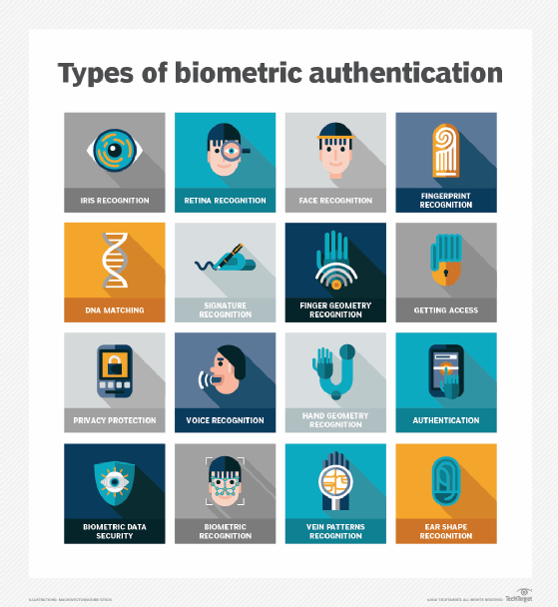
What is biometric authentication?
Biometric authentication is a security process that relies on the unique biological characteristics of individuals to verify they are who they say they are. Biometric authentication systems compare physical or behavioural traits to stored, confirmed, authentic data in a database. If both samples of the biometric data match, authentication is confirmed. Typically, biometric authentication is used to manage access to physical and digital resources, such as buildings, rooms and computing devices.
Biometric identification uses biometrics, such as fingerprints or retina scans, to identify a person, whereas biometric authentication is the use of biometrics to verify people are who they claim to be.
What benefits do biometric security systems offer?
- Biometric systems strengthen security
One of the key benefits of biometric security devices is that they can help to increase your protection. It’s much harder, for example, to clone or steal a fingerprint than an access card.
In situations where you need to increase security, biometrics can also be used for multifactor verification. After someone’s presented their badge, for example, they then need to present their fingerprint to verify that they are who they claim to be. This is safer than using a PIN for verification as that can easily be passed to other people.
- Biometric systems improve convenience
Biometric security systems can also offer users more convenience. It’s easy to forget a card or key, but you always have your biometrics with you. And if the identifier allows handsfree or long-distance recognition, the convenience levels increase further – you may be allowed to enter your building simply by having your face scanned as you pass the entrance.
Are there downsides to biometric security solutions?
Although biometric security systems offer many advantages, there are still some concerns and even potential risks to consider.
Accuracy
Although the probability of identifying someone via a biometric system is high, 100% accuracy isn’t guaranteed. Each biometric recognition technology has its own false acceptance rate and false rejection rate, and factors such as sunlight and the cleanliness of the sensor can affect accuracy.
Privacy
As biometrics are classified as sensitive personal data in European General Data Protection Regulation (GDPR), it’s important to use and store biometric information in line with local regulations. In some countries, for example, you’re not allowed to store any biometric data in a central database.
Enrolment issues
Factors such as dry fingers, vague fingerprints, eye disease or exceptionally dark irises mean that a small number of people can’t be enrolled using some biometric recognition technologies.
Fraudulent use
Presenting a photo of a fingerprint or face can fool some biometric systems and create opportunities to breach security. In some biometric security solutions, it’s possible to add liveness detection as extra functionality. This checks that the body part presented is from a living person who is at the sensor there and then.
Some inconvenience
Users must be physically present for registration using biometric identifiers, whereas an access card or PIN can be prepared in advance. Biometric security systems are often slower to use too, which can be a problem if large numbers of people need to gain access within a certain timeframe.
GDPR compliance
In some countries, to comply with local privacy regulations, biometric templates must be stored on access cards rather than in a separate database. The upside of this is that each person owns and carries their own biometric template, and if their card is lost or stolen only they are affected. The downside is that biometrics can only be used for verification as identification is still done by the access card. Also, templates stored on cards often have a lower resolution, which makes comparing characteristics more difficult.

KT0104 Web content filters

What Is Content Filtering?
Content filtering is the screening and exclusion of access to email or web pages that are undesirable. Content filtering solutions operate by stipulating content patterns, including text strings or image aspects. If these patterns are matched, the software labels the content objectionable and proceeds to block or flag it somehow.
Web content filtering, also known as content filtering, is a set of solutions that monitor and restrict access to web content that can be deemed inappropriate, offensive, or risky. Corporations make use of content filtering through firewalls. While not common, home computer owners also use content filtering solutions. At home, content filters protect young children from age-inappropriate content, while the corporate world uses this solution to block access to specific types of content.

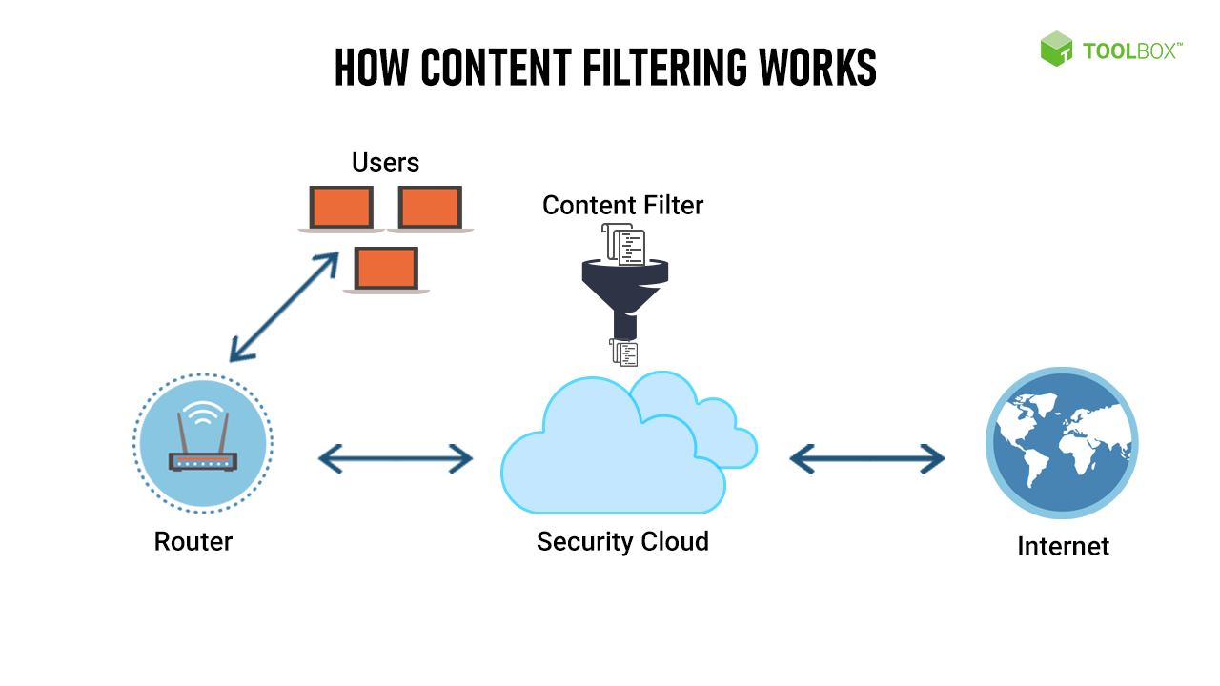
How Content Filtering Works
Many leading internet firewalls offer content filters as a built-in feature, either as hardware or software. The dual advantage of content filtering is cybersecurity and the implementation of company policies related to the usage of corporate information systems. For instance, these filters will block dangerous sites (cybersecurity) and inappropriate social networking sites (as per company policy).
Today, corporations strive to create safe workplaces with minimum disruptions. Content filters play a significant role in the achievement of this goal. At the workplace, inappropriate or illegal content should not be accessible, as this could create a liability for the organization and compromise employee well-being or system integrity.
For instance, pornographic content could easily lead to sexual harassment and a hostile or demeaning work environment, while spam websites pose a high risk of transmitting malware onto work computers. Other examples of malicious content include websites with hateful or violent content that may compromise employee safety and the company’s image and social networking sites that tend to hamper the productivity and efficiency of employees.
Content filtering solutions project a clear demarcation in terms of company policy around these issues by blocking access to harmful websites at the workplace. This also helps demonstrate the intolerance of the organization for illegal, objectionable, or otherwise inappropriate content in general.
Content filtering channels
The efficacy of content filtering can be maximized by deploying such solutions across channels, including:
- Email: Today, and especially during remote working conditions, email is the primary mode of communication for most organizations. Emails are also heavily targeted by spammers and are among the most likely mediums for malware and other undesirable content. Content filters maximize the safety of emails through a variety of methods. These solutions scan the content of the email. If specific words, phrases, attachment types, or other content is detected, they place the email in the recipient’s junk folder or even mark it ‘undeliverable’ and bounce it back.
- Web: The internet is the lifeblood of corporations worldwide, and content filtering solutions help keep a company’s resources secure by filtering web traffic according to a set of predefined rules.
- Program files: Not all employees are tech-savvy. Sometimes, an employee may try to download and run a program that is malicious in nature. Content filtering works to block such program files before they can harm the user’s system or the company’s network.
The aim behind implementing content filters is to block access to content that may be deemed objectionable. Such restrictions are applicable across levels—from a single home user blocking spam to the government of a country applying regulations nationwide. Socio-political and ethical issues aside, the scope of content filtering is vast, and these solutions can serve as a step toward robust personal, organizational, and national cybersecurity.
Types of Content Filtration
The internet, aptly known as the ‘information superhighway’, is a boon for knowledge transfer. However, it has never been a truly secure medium for the dissemination of content. The casual user of the internet is always susceptible to bad information, malware, and other harmful elements. Therefore, content filters must be used to protect the people and systems browsing the internet.
Content filters help employers, system administrators, governments, and personal users protect themselves and their dependents from unwanted material. Due to the wide scope of applications, there are different types of content filters, most of which can be customized to meet the needs of specific users.
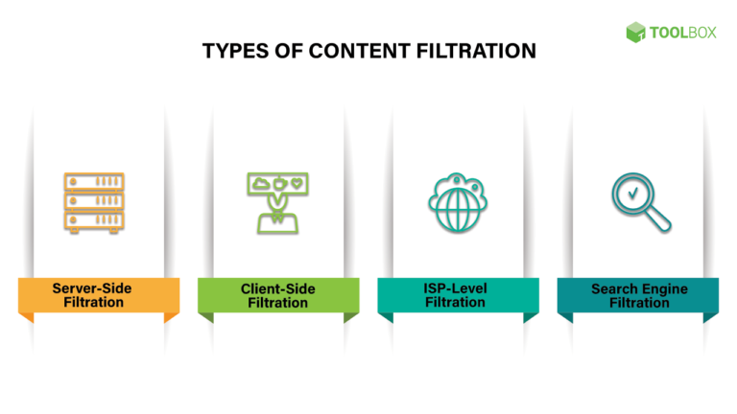
Types of Content Filtration
1. Server-side filtration
Server-side content filters manage web traffic for every user of a specific network. The provider or administrator will install server-side content filters on a central server that links to all computers on the network. Such content filtering solutions are useful for monitoring internet usage in large organizations.
Since these solutions are server-based, they allow administrators to create one set of rules for filtering content and apply it to all users on the network. Unlike ISP-based filtration, complete control is retained by the company, making customization dynamic and straightforward.
Assigning different levels of access to different classes of users becomes very easy in server-side content filters. Many solution providers offer prebuilt content filters that only require minor tweaks at the organizational level.
2. Client-side filtration
A client-side content filter is installed on the end user’s system. However, the end-user may not be able to modify or uninstall it. This restriction is usually achieved by password-protecting the program or restricting the capabilities of the end-user system through admin privileges.
By restricting the operations of the client-side filter, the administrator can rest assured that the client will not be able to bypass its restrictions. Client-side filters are well-suited for home use.
They are also apt for business environments that require filtration for specific computers. However, it becomes tedious (or, in some cases, close to impossible) to manage client-side content filters as the size of the organization increases.
3. ISP-level filtration
For far-reaching content filtration, an internet service provider (ISP) may restrict web traffic based on rules set by an organization or government. When the ISP implements content filtering, these restrictions affect every user.
The ISP can filter inappropriate web traffic as well as monitor chat and emails. Like other types of content filters, ISPs too can dynamically block or unblock services as the guidelines get updated. Based on the service provider policy in force, ISPs can allow clients to pick the types of content to be filtered for specific user classes.
However, it should be noted that delegating content filtering to an ISP removes direct control and elongates the modification process in case changes are required.
4. Search engine filtration
With remote work becoming the norm during the COVID-19 pandemic, solutions such as Google Workspace and Microsoft 365 for Business enable organizations to control user activities without the need for a VPN or client-side software. By taking control of employee web traffic, employers can implement additional security filters remotely.
When these filters are turned on, search engines will only display results that are in line with company policy. Further, inappropriate content that is not explicitly blocked by the organization but deemed harmful by the solution provider may be blocked as well.
However, it is worth noting that search engine filtration is not the same as URL filtration. While there may be a certain level of overlap among the two, employees who already know the URL of a website that is not specifically blocked may still be able to access it without having to use a search engine.
At the home level, some search engines such as Kidde and Wacky Safe offer filters that are oriented towards kids. The search results of these providers are pre-filtered to ensure that they are appropriate for children.
Such content filters are beneficial as they allow kids and other dependents to browse the internet without supervision while ensuring that they stay away from websites that are known to contain unsafe or inappropriate content.

KT0105 Need for protection of privacy and data
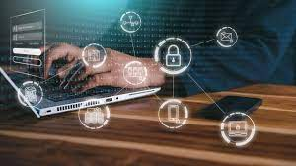
The terms data protection and data privacy are often used interchangeably, but there is an important difference between the two. Data privacy defines who has access to data, while data protection provides tools and policies to actually restrict access to the data. Compliance regulations help ensure that user’s privacy requests are carried out by companies, and companies are responsible to take measures to protect private user data.
Data protection and privacy is typically applied to personal health information (PHI) and personally identifiable information (PII). It plays a vital role in business operations, development, and finances. By protecting data, companies can prevent data breaches, damage to reputation, and can better meet regulatory requirements.
Data protection solutions rely on technologies such as data loss prevention (DLP), storage with built-in data protection, firewalls, encryption, and endpoint protection.

What Is Data Protection and Why Is It Important?
Data protection is a set of strategies and processes you can use to secure the privacy, availability, and integrity of your data. It is sometimes also called data security.
A data protection strategy is vital for any organization that collects, handles, or stores sensitive data. A successful strategy can help prevent data loss, theft, or corruption and can help minimize damage caused in the event of a breach or disaster.
What Are Data Protection Principles?
Data protection principles help protect data and make it available under any circumstances. It covers operational data backup and business continuity/disaster recovery (BCDR) and involves implementing aspects of data management and data availability.
Here are key data management aspects relevant to data protection:
- Data availability—ensuring users can access and use the data required to perform business even when this data is lost or damaged.
- Data lifecycle management—involves automating the transmission of critical data to offline and online storage.
- Information lifecycle management—involves the valuation, cataloguing, and protection of information assets from various sources, including facility outages and disruptions, application and user errors, machine failure, and malware and virus attacks.
What Is Data Privacy and Why Is it Important?
Data privacy is a guideline for how data should be collected or handled, based on its sensitivity and importance. Data privacy is typically applied to personal health information (PHI) and personally identifiable information (PII). This includes financial information, medical records, social security or ID numbers, names, birthdates, and contact information.
Data privacy concerns apply to all sensitive information that organizations handle, including that of customers, shareholders, and employees. Often, this information plays a vital role in business operations, development, and finances.
Data privacy helps ensure that sensitive data is only accessible to approved parties. It prevents criminals from being able to maliciously use data and helps ensure that organizations meet regulatory requirements.
What Are Data Protection Regulations?
Data protection regulations govern how certain data types are collected, transmitted, and used. Personal data includes various types of information, including names, photos, email addresses, bank account details, IP addresses of personal computers, and biometric data.
Data protection and privacy regulations vary between countries, states, and industries. For example, China has created a data privacy law that went into effect on June 1, 2017, and the European Union’s (EU) General Data Protection Regulation (GDPR) went into effect during 2018. Non-compliance may result in reputation damages and monetary fines, depending on the violation as instructed by each law and governing entity.
Compliance with one set of regulations does not guarantee compliance with all laws. Additionally, each law contains numerous clauses that may apply to one case but not another, and all regulations are subject to changes. This level of complexity makes it difficult to implement compliance consistently and appropriately.
Data Protection vs Data Privacy
Although both data protection and privacy are important and the two often come together, these terms do not represent the same thing.
One addresses policies, the other mechanisms
Data privacy is focused on defining who has access to data while data protection focuses on applying those restrictions. Data privacy defines the policies that data protection tools and processes employ.
Creating data privacy guidelines does not ensure that unauthorized users don’t have access. Likewise, you can restrict access with data protections while still leaving sensitive data vulnerable. Both are needed to ensure that data remains secure.
Users control privacy, companies ensure protection
Another important distinction between privacy and protection is who is typically in control. For privacy, users can often control how much of their data is shared and with whom. For protection, it is up to the companies handling data to ensure that it remains private. Compliance regulations reflect this difference and are created to help ensure that users’ privacy requests are enacted by companies.
Data Protection Technologies and Practices to Protect Your Data
When it comes to protecting your data, there are many storage and management options you can choose from. Solutions can help you restrict access, monitor activity, and respond to threats. Here are some of the most commonly used practices and technologies:
- Data discovery—a first step in data protection, this involves discovering which data sets exist in the organization, which of them are business critical and which contains sensitive data that might be subject to compliance regulations.
- Data loss prevention (DLP)—a set of strategies and tools that you can use to prevent data from being stolen, lost, or accidentally deleted. Data loss prevention solutions often include several tools to protect against and recover from data loss.
- Storage with built-in data protection—modern storage equipment provides built-in disk clustering and redundancy. For example, Cloudian’s Hyperstore provides up to 14 nines of durability, low cost enabling storage of large volumes of data, and fast access for minimal RTO/RPO.
- Backup—creates copies of data and stores them separately, making it possible to restore the data later in case of loss or modification. Backups are a critical strategy for ensuring business continuity when original data is lost, destroyed, or damaged, either accidentally or maliciously.
- Snapshots—a snapshot is similar to a backup, but it is a complete image of a protected system, including data and system files. A snapshot can be used to restore an entire system to a specific point in time.
- Replication—a technique for copying data on an ongoing basis from a protected system to another location. This provides a living, up-to-date copy of the data, allowing not only recovery but also immediate failover to the copy if the primary system goes down.
- Firewalls—utilities that enable you to monitor and filter network traffic. You can use firewalls to ensure that only authorized users are allowed to access or transfer data.
- Authentication and authorization—controls that help you verify credentials and assure that user privileges are applied correctly. These measures are typically used as part of an identity and access management (IAM) solution and in combination with role-based access controls (RBAC).
- Encryption—alters data content according to an algorithm that can only be reversed with the right encryption key. Encryption protects your data from unauthorized access even if data is stolen by making it unreadable.
- Endpoint protection—protects gateways to your network, including ports, routers, and connected devices. Endpoint protection software typically enables you to monitor your network perimeter and to filter traffic as needed.
- Data erasure—limits liability by deleting data that is no longer needed. This can be done after data is processed and analysed or periodically when data is no longer relevant. Erasing unnecessary data is a requirement of many compliance regulations, such as GDPR. For more information about GDPR, check out our guide: GDPR Data Protection.
- Disaster recovery—a set of practices and technologies that determine how an organization deals with a disaster, such as a cyber attack, natural disaster, or large-scale equipment failure. The disaster recovery process typically involves setting up a remote disaster recovery site with copies of protected systems, and switching operations to those systems in case of disaster.

Internal Assessment Criteria and Weight
- IAC0101The importance of computer and mobile device security is justified.
- IAC0102Objectives of computer and mobile device security are explained

KM-01-KT02: Various computer and network security threats
Topic elements to be covered include:
- KT0201Malware.
- KT0202Viruses.
- KT0203Spyware.
- KT0204Adware.
- KT0205Trojan horses.
- KT0206Worms.
- KT0207Phishing.
- KT0208Spear phishing.
- KT0209Insider security threats

KT0201 Malware.
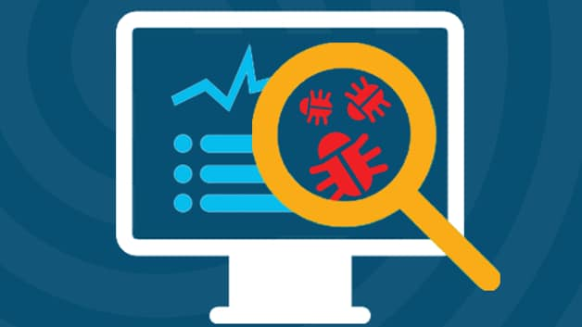
What is Malware?
Malware is intrusive software that is designed to damage and destroy computers and computer systems. Malware is a contraction for “malicious software.” Examples of common malware includes viruses, worms, Trojan viruses, spyware, adware, and ransomware.

Malware, short for “malicious software,” refers to any intrusive software developed by cybercriminals (often called “hackers”) to steal data and damage or destroy computers and computer systems. Examples of common malware include viruses, worms, Trojan viruses, spyware, adware, and ransomware. Recent malware attacks have exfiltrated data in mass amounts.
Types of malwares
There are a number of different ways of categorizing malware; the first is by how the malicious software spreads. You've probably heard the words virus, trojan, and worm used interchangeably, but as Symantec explains, they describe three subtly different ways malware can infect target computers:
- A worm is a standalone piece of malicious software that reproduces itself and spreads from computer to computer.
- A virus is a piece of computer code that inserts itself within the code of another standalone program, then forces that program to take malicious action and spread itself.
- A trojan is a program that cannot reproduce itself but masquerades as something the user wants and tricks them into activating it so it can do its damage and spread.
Malware can also be installed on a computer "manually" by the attackers themselves, either by gaining physical access to the computer or using privilege escalation to gain remote administrator access.
Another way to categorize malware is by what it does once it has successfully infected its victim's computers. There are a wide range of potential attack techniques used by malware:
- Spyware is defined by Webroot Cybersecurity as "malware used for the purpose of secretly gathering data on an unsuspecting user." In essence, it spies on your behaviour as you use your computer, and on the data you send and receive, usually with the purpose of sending that information to a third party. A keylogger is a specific kind of spyware that records all the keystrokes a user makes—great for stealing passwords.
- A rootkit is, as described by TechTarget, "a program or, more often, a collection of software tools that gives a threat actor remote access to and control over a computer or other system." It gets its name because it's a kit of tools that (generally illicitly) gain root access (administrator-level control, in Unix terms) over the target system, and use that power to hide their presence.
- Adware is malware that forces your browser to redirect to web advertisements, which often themselves seek to download further, even more malicious software. Adware often piggybacks onto tempting "free" programs like games or browser extensions.
- Ransomware is a flavour of malware that encrypts your hard drive's files and demands a payment, usually in Bitcoin, in exchange for the decryption key. Several high-profile malware outbreaks of the last few years, such as Petya, are ransomware. Without the decryption key, it's mathematically impossible for victims to regain access to their files. So-called scareware is a sort of shadow version of ransomware; it claims to have taken control of your computer and demands a ransom, but actually is just using tricks like browser redirect loops to make it seem as if it's done more damage than it really has, and unlike ransomware can be relatively easily disabled.
- Crypto jacking is another way attackers can force you to supply them with Bitcoin—only it works without you necessarily knowing. The crypto mining malware infects your computer and uses your CPU cycles to mine Bitcoin for your attacker's profit. The mining software may run in the background on your operating system or even as JavaScript in a browser window.
- Malvertising is the use of legitimate ads or ad networks to covertly deliver malware to unsuspecting users’ computers. For example, a cybercriminal might pay to place an ad on a legitimate website. When a user clicks on the ad, code in the ad either redirects them to a malicious website or installs malware on their computer. In some cases, the malware embedded in an ad might execute automatically without any action from the user, a technique referred to as a “drive-by download.”
Any specific piece of malware has both a means of infection and a behavioural category. So, for instance, WannaCry is a ransomware worm. And a particular piece of malware might have different forms with different attack vectors: for instance, the Emoted banking malware has been spotted in the wild as both a trojan and a worm.

How do I protect my network against malware?
Typically, businesses focus on preventative tools to stop breaches. By securing the perimeter, businesses assume they are safe. Some advanced malware, however, will eventually make their way into your network. As a result, it is crucial to deploy technologies that continually monitor and detect malware that has evaded perimeter defences. Sufficient advanced malware protection requires multiple layers of safeguards along with high-level network visibility and intelligence.
How do I detect and respond to malware?
Malware will inevitably penetrate your network. You must have defences that provide significant visibility and breach detection. In order to remove malware, you must be able to identify malicious actors quickly. This requires constant network scanning. Once the threat is identified, you must remove the malware from your network. Today's antivirus products are not enough to protect against advanced cyber threats

KT0202 Viruses.

Definition of Computer Viruses
A computer virus is a type of malicious software, or malware, that spreads between computers and causes damage to data and software.
Computer viruses aim to disrupt systems, cause major operational issues, and result in data loss and leakage. A key thing to know about computer viruses is that they are designed to spread across programs and systems. Computer viruses typically attach to an executable host file, which results in their viral codes executing when a file is opened. The code then spreads from the document or software it is attached to via networks, drives, file-sharing programs, or infected email attachments.
Common Signs of Computer Viruses
A computer virus will more than likely have an adverse effect on the device it resides on and may be discoverable through common signs of performance loss, including:
Speed of System
A computer system running slower than usual is one of the most common signs that the device has a virus. This includes the system itself running slowly, as well as applications and internet speed suffering. If a computer does not have powerful applications or programs installed and is running slowly, then it may be a sign it is infected with a virus.
Pop-up Windows
Unwanted pop-up windows appearing on a computer or in a web browser are a tell-tale sign of a computer virus. Unwanted pop-ups are a sign of malware, viruses, or spyware affecting a device.
Programs Self-executing
If computer programs unexpectedly close by themselves, then it is highly likely that the software has been infected with some form of virus or malware. Another indicator of a virus is when applications fail to load when selected from the Start menu or their desktop icon.
Accounts Being Logged Out
Some viruses are designed to affect specific applications, which will either cause them to crash or force the user to automatically log out of the service.
Crashing of the Device
System crashes and the computer itself unexpectedly closing down are common indicators of a virus. Computer viruses cause computers to act in a variety of strange ways, which may include opening files by themselves, displaying unusual error messages, or clicking keys at random.
Mass Emails Being Sent from Your Email Account
Computer viruses are commonly spread via email. Hackers can use other people's email accounts to spread malware and carry out wider cyberattacks. Therefore, if an email account has sent emails in the outbox that a user did not send, then this could be a sign of a computer virus.
Changes to Your Homepage
Any unexpected changes to a computer—such as your system’s homepage being amended or any browser settings being updated—are signs that a computer virus may be present on the device.
How Do Computer Viruses Attack and Spread?
In the early days of computers, viruses were spread between devices using floppy disks. Nowadays, viruses can still be spread via hard disks and Universal Serial Bus (USB) devices, but they are more likely to be passed between devices through the internet.
Computer viruses can be spread via email, with some even capable of hijacking email software to spread themselves. Others may attach to legitimate software, within software packs, or infect code, and other viruses can be downloaded from compromised application stores and infected code repositories. A key feature of any computer virus is it requires a victim to execute its code or payload, which means the host application should be running.
Types of Computer Viruses
There are several types of computer viruses that can infect devices. This section will cover computer virus protections and how to get rid of computer viruses.
Resident Virus
Viruses propagate themselves by infecting applications on a host computer. A resident virus achieves this by infecting applications as they are opened by a user. A non-resident virus is capable of infecting executable files when programs are not running.
Multipartite Virus
A multipartite virus uses multiple methods to infect and spread across computers. It will typically remain in the computer’s memory to infect the hard disk, then spread through and infect more drives by altering the content of applications. This results in performance lag and application memory running low.
Multipartite viruses can be avoided by not opening attachments from untrusted sources and by installing trusted antivirus software. It can also be prevented by cleaning the boot sector and the computer’s entire disk.
Direct Action
A direct-action virus accesses a computer’s main memory and infects all programs, files, and folders located in the autoexec.bat path, before deleting itself. This virus typically alters the performance of a system but is capable of destroying all data on the computer’s hard disk and any USB device attached to it. Direct action viruses can be avoided through the use of antivirus scanners. They are easy to detect, as is restoring infected files.
Browser Hijacker
A browser hijacker manually changes the settings of web browsers, such as replacing the homepage, editing the new tab page, and changing the default search engine. Technically, it is not a virus because it cannot infect files but can be hugely damaging to computer users, who often will not be able to restore their homepage or search engine. It can also contain adware that causes unwanted pop-ups and advertisements.
Browser hijackers typically attach to free software and malicious applications from unverified websites or app stores, so only use trusted software and reliable antivirus software.
Overwrite Virus
Overwrite viruses are extremely dangerous. They can delete data and replace it with their own file content or code. Once files get infected, they cannot be replaced, and the virus can affect Windows, DOS, Linux, and Apple systems. The only way this virus can be removed is by deleting all of the files it has infected, which could be devastating. The best way to protect against the overwrite virus is to use a trusted antivirus solution and keep it updated.
Web Scripting Virus
A web scripting virus attacks web browser security, enabling a hacker to inject web-pages with malicious code, or client-side scripting. This allows cyber criminals to attack major websites, such as social networking sites, email providers, and any site that enables user input or reviews. Attackers can use the virus to send spam, commit fraudulent activity, and damage server files.
Protecting against web scripting is reliant on deploying real-time web browser protection software, using cookie security, disabling scripts, and using malicious software removal tools.
File Infector
A file infector is one of the most common computer viruses. It overwrites files when they are opened and can quickly spread across systems and networks. It largely affects files with .exe or .com extensions. The best way to avoid file infector viruses is to only download official software and deploy an antivirus solution.
Network Virus
Network viruses are extremely dangerous because they can completely cripple entire computer networks. They are often difficult to discover, as the virus could be hidden within any computer on an infected network. These viruses can easily replicate and spread by using the internet to transfer to devices connected to the network. Trusted, robust antivirus solutions and advanced firewalls are crucial to protecting against network viruses.
Boot Sector Virus
A boot sector virus targets a computer’s master boot record (MBR). The virus injects its code into a hard disk’s partition table, then moves into the main memory when a computer restarts. The presence of the virus is signified by boot-up problems, poor system performance, and the hard disk becoming unable to locate. Most modern computers come with boot sector safeguards that restrict the potential of this type of virus.
Steps to protecting against a boot sector virus include ensuring disks are write-protected and not starting up a computer with untrusted external drives connected.

KT0203 Spyware.
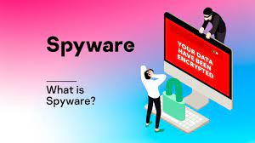
What is Spyware?
Spyware is malicious software that enters a user’s computer, gathers data from the device and user, and sends it to third parties without their consent. A commonly accepted spyware definition is a strand of malware designed to access and damage a device without the user’s consent.
Spyware collects personal and sensitive information that it sends to advertisers, data collection firms, or malicious actors for a profit. Attackers use it to track, steal, and sell user data, such as internet usage, credit card, and bank account details, or steal user credentials to spoof their identities.
Spyware is one of the most commonly used cyberattack methods that can be difficult for users and businesses to identify and can do serious harm to networks. It also leaves businesses vulnerable to data breaches and data misuse, often affects device and network performance, and slows down user activity.
The term "spyware" first emerged in online discussions in the 1990s, but only in the early 2000s did cybersecurity firms use it to describe unwanted software that spied on their user and computer activity. The first anti-spyware software was released in June 2000, then four years later, scans showed that around 80% of internet users had their systems affected by spyware, according to research by America Online and the National Cyber Security Alliance. However, 89% of users were unaware of the spyware’s existence and 95% had not granted permission for it to be installed.

Types of Spyware
Attackers use various types of spyware to infect users’ computers and devices. Each spyware variety gathers data for the attacker, with the lesser types monitoring and sending data to a third party. But more advanced and dangerous spyware types will also make modifications to a user’s system that results in them being exposed to further threats.
Some of the most commonly used types of spyware include:
- Adware: This sits on a device and monitors users’ activity then sells their data to advertisers and malicious actors or serves up malicious ads.
- Info stealer: This is a type of spyware that collects information from devices. It scans them for specific data and instant messaging conversations.
- Keyloggers: Also known as keystroke loggers, keyloggers are a type of info stealer spyware. They record the keystrokes that a user makes on their infected device, then save the data into an encrypted log file. This spyware method collects all of the information that the user types into their devices, such as email data, passwords, text messages, and usernames.
- Rootkits: These enable attackers to deeply infiltrate devices by exploiting security vulnerabilities or logging into machines as an administrator. Rootkits are often difficult and even impossible to detect.
- Red Shell: This spyware installs itself onto a device while a user is installing specific PC games, then tracks their online activity. It is generally used by developers to enhance their games and improve their marketing campaigns.
- System monitors: These also track user activity on their computer, capturing information like emails sent, social media and other sites visited, and keystrokes.
- Tracking cookies: Tracking cookies are dropped onto a device by a website and then used to follow the user’s online activity.
- Trojan Horse Virus: This brand of spyware enters a device through Trojan malware, which is responsible for delivering the spyware program.
Most spyware targets Windows computers and laptops, but attackers are increasingly targeting other forms of devices.
- Apple device spyware: Malware targeting Apple devices, particularly its Mac computers, has increased rapidly in the last few years. Mac spyware is similar in behaviour to those targeting Windows operating systems but are typically password-stealing or backdoor types of spyware. They frequently see the attacker attempt attacks such as keylogging, password phishing, remote code execution, and screen captures.
- Mobile spyware: Spyware targeting mobile devices steals data such as call logs, browser history, contact lists, photos, and short message service (SMS) messages. Certain types will log user keystrokes, record using the device’s microphone, take photos, and track location using Global Positioning System (GPS) trackers. Others take control of devices through commands sent from SMS messages, data transfers, and remote servers. Hackers can also use mobile spyware to breach an organization through mobile device vulnerabilities, which may not be detected by the security team.
What Does Spyware Do?
All types of spyware sit on a user’s device and spy on their activity, the sites they visit, and the data they amass or share. They do this with the objective of monitoring user activity, tracking login and password details, and detecting sensitive data.
Other spyware strands are also capable of installing further software on the user’s device, which enables the attacker to make changes to the device. But spyware typically follows a three-step process from being installed on a device to sending or selling the information it has stolen.
- Step 1—Infiltrate: Spyware is installed onto a device through the use of an application installation package, a malicious website, or as a file attachment.
- Step 2—Monitor and capture: Once installed, the spyware gets to work following the user around the internet, capturing the data they use, and stealing their credentials, login information, and passwords. It does this through screen captures, keystroke technology, and tracking codes.
- Step 3—Send or sell: With data and information captured, the attacker will either use the data amassed or sell it to a third party. If they use the data, they could take the user credentials to spoof their identity or use them as part of a larger cyberattack on a business. If they sell, they could use the data for a profit with data organizations, other hackers, or put it on the dark web.

KT0204 Adware.
Adware definition

Adware, also known as advertisement-supported software, generates revenue for its developers by automatically generating adverts on your screen, usually within a web browser. Adware is typically created for computers but can also be found on mobile devices. Some forms of adware are highly manipulative and create an open door for malicious programs.
What is adware?
Adware is software that displays unwanted (and sometimes irritating) pop-up adverts which can appear on your computer or mobile device. Adware typically ends up on a user’s device through one of two ways:
- You might install a free computer program or app without necessarily realizing that it contains additional software that contains adware. This allows the app developer to make money but means you could download adware onto your systems without necessarily consenting.
- Alternatively, there may be a vulnerability in your software or operating system which hackers exploit to insert malware, including some types of adware, into your system.
How do you get adware?
Adware normally comes in software/programs that you download from the internet – usually freeware or shareware – and it secretly installs itself onto your device without your knowledge.
Free software which contains some ads may be annoying but is not illegal. However, if a third-party program adds malicious ad software onto your device without your consent, then it is illegal.
How does adware work?
Adware works by installing itself quietly onto your devices, hoping you’ll – accidentally or otherwise – click on an advert that it displays to you.
This is because, ultimately, adware exists to make money.
Adware creators and distributing vendors make money from third parties via either:
- Pay-per-click (PPC) — they get paid each time you open an ad.
- Pay-per-view (PPV) — they get paid each time an ad is shown to you.
- Pay-per-install (PPI) — they get paid each time bundled software is installed on a device.
Adware can also track your search and browsing history to display ads that are more relevant to you. Once the developer has your location and browser history, they can make additional income by selling that information to third parties.
At the less harmful end of the spectrum, adware is simply a nuisance. At the more harmful end, it can be a damaging malware threat to your cybersecurity.
Types of adware
It is important to distinguish between harmless and harmful adware. Adware examples include:
Legitimate adware that allows you to consent to ads and software promos, offsetting developer costs so they can offer their software for free. Users willingly download this type of adware to get a free product. Also, you might choose to allow it to collect marketing information. Sometimes the accompanying personalized ads or sponsored third-party software can be desirable.
Legitimate adware is created by all types of developers, including reputable ones. It is a valid and legal way to give customers a free product.
However, not all application downloads are consensual. This is where legal boundaries become blurred.
Potentially unwanted applications (PUAs) include any program you might not have chosen to install onto your device. These may also be called potentially unwanted programs (PUPs).
PUA adware can fall into a Gray area, where the extent to which it is malicious or illegal depends on the goals of the software and those who distribute it:
- Legal deceptive adware PUA may actively make it tricky to opt-out of installing harmless third-party software. While frustrating, legitimate adware sometimes uses this method. It is legal if the creator has not knowingly included malware-tainted ads or software. Unfortunately, some adware might unknowingly deliver disguised malware to devices.
- Legal abusive adware PUA is designed to bombard you with ads. Excessive ads may be in adware itself or in packaged software via web browser toolbars or other means. Without any malware, this is also legal. Ads for things like pornography or fitness pills frequently appear in adware like this.
- Illegal malicious adware PUA profits from malicious third parties who want to distribute malicious software like spyware, viruses, or other malware onto devices. This malware may be intentionally masked within the adware itself, the websites it advertises, or in accompanying software. The creators and distributors knowingly spread this threat and might use abusive methods to accomplish it.
When people talk about “adware,” they tend to mean the programs that abuse ads and open the door for malware.
Adware can be frustrating regardless of legality and can easily go undetected for a long time. To avoid any invasive or tedious software, you should know what to look for.
How to tell if you have an adware infection
Signs that you may be infected with unwanted adware include:
Computer adware infection signs
- An unexpected change in your web browser home page
- Web pages that you visit not displaying correctly
- Being overwhelmed with pop-up ads — sometimes even if not browsing the internet
- Slow device performance
- Device crashing
- Reduced internet speeds
- Redirected internet searches
- Random appearance of a new toolbar or browser add-on
Mobile adware infection signs
On your phone, signs are similar:
- Your phone is slow
- Apps take longer to load
- Your battery drains quickly
- Your phone has apps you don’t remember downloading
- There is unexplained data usage and higher than expected phone bills
- There are numerous ad pop-ups
Some adware is aggressive – it embeds itself deep into systems with rootkits to make removal challenging. If you are infected, you’ll need to take steps to clean your system of the offending applications.

Mobile adware
Adware can get onto people’s mobile or cell phones through apps in popular categories like entertainment and gaming. These apps can appear harmless but, once installed, can behave maliciously.
Again, there is a spectrum from relatively harmless to far more harmful. At the harmless end, you may download an app that simply spams you with ads once it has been installed. This can be a nuisance, especially because sometimes the ads can appear from outside the app, making it hard to identify the cause.
Far more harmful is ad fraud and ad clicker software. This involves apps surreptitiously downloading executable files and running malicious activities in the background. This can include clicking on ads without users knowing or subscribing users to premium services that they then have to pay for.
How to remove adware
Adware removal will help fix adware problems like obnoxious pop-ups and hidden spyware.
Manual removal does not guarantee you’ll find all the components. For a reliable solution, cybersecurity software will help you clean anything you wouldn’t find on your own.
To break it down, you’ll need to detect and take action on each of the following issues:
- Adware: Legitimate ad-supported software may be fine to keep — as long as it operates with your consent. Adware or third-party software becomes PUA when it was either installed without your knowledge or does things you wouldn’t like it to do.
- Adware PUA: Adware and sponsored third-party software can be obnoxious at best and a gateway for actual malware at worst. Either way, you’ll likely want to remove these.
- Malware infections: Malicious programs may have already infiltrated your system. You’ll need to remove these to stop the immediate threats to your privacy.

KT0205 Trojan horses.
What Is a Trojan Horse Virus?
A Trojan Horse Virus is a type of malware that downloads onto a computer disguised as a legitimate program. The delivery method typically sees an attacker use social engineering to hide malicious code within legitimate software to try and gain users' system access with their software.
A simple way to answer the question "what is Trojan" is it is a type of malware that typically gets hidden as an attachment in an email or a free-to-download file, then transfers onto the user’s device. Once downloaded, the malicious code will execute the task the attacker designed it for, such as gain backdoor access to corporate systems, spy on users’ online activity, or steal sensitive data.
Indications of a Trojan being active on a device include unusual activity such as computer settings being changed unexpectedly.
History of the Trojan Horse
The original story of the Trojan horse can be found in the Aeneid by Virgil and the Odyssey by Homer. In the story, the enemies of the city of Troy were able to get inside the city gates using a horse they pretended was a gift. The soldiers hid inside the huge wooden horse and once inside, they climbed out and let the other soldiers in.
There are a few elements of the story that make the term “Trojan horse” an appropriate name for these types of cyber-attacks:
- The Trojan horse was a unique solution to the target’s defenses. In the original story, the attackers had laid siege to the city for 10 years and hadn’t succeeded in defeating it. The Trojan horse gave them the access they had been wanting for a decade. A Trojan virus, similarly, can be a good way to get behind an otherwise tight set of defenses.
- The Trojan horse appeared to be a legitimate gift. In a similar vein, a Trojan virus looks like legitimate software.
- The soldiers in the Trojan horse controlled the city’s defense system. With a Trojan virus, the malware takes control of your computer, potentially leaving it vulnerable to other “invaders.”

How Do Trojans Work?
Unlike computer viruses, a Trojan horse cannot manifest by itself, so it needs a user to download the server side of the application for it to work. This means the executable (.exe) file should be implemented and the program installed for the Trojan to attack a device’s system.
A Trojan virus spreads through legitimate-looking emails and files attached to emails, which are spammed to reach the inboxes of as many people as possible. When the email is opened and the malicious attachment is downloaded, the Trojan server will install and automatically run every time the infected device is turned on.
Devices can also be infected by a Trojan through social engineering tactics, which cyber criminals use to coerce users into downloading a malicious application. The malicious file could be hidden in banner advertisements, pop-up advertisements, or links on websites.
A computer infected by Trojan malware can also spread it to other computers. A cybercriminal turns the device into a zombie computer, which means they have remote control of it without the user knowing. Hackers can then use the zombie computer to continue sharing malware across a network of devices, known as a botnet.
For example, a user might receive an email from someone they know, which includes an attachment that also looks legitimate. However, the attachment contains malicious code that executes and installs the Trojan on their device. The user often will not know anything untoward has occurred, as their computer may continue to work normally with no signs of it having been infected.
The malware will reside undetected until the user takes a certain action, such as visiting a certain website or banking app. This will activate the malicious code, and the Trojan will carry out the hacker’s desired action. Depending on the type of Trojan and how it was created, the malware may delete itself, return to being dormant, or remain active on the device.
Trojans can also attack and infect smartphones and tablets using a strand of mobile malware. This could occur through the attacker redirecting traffic to a device connected to a Wi-Fi network and then using it to launch cyberattacks.
Most Common Types of Trojan Malware
There are many types of Trojan horse viruses that cyber criminals use to carry out different actions and different attack methods. The most common types of Trojans used include:
- Backdoor Trojan: A backdoor Trojan enables an attacker to gain remote access to a computer and take control of it using a backdoor. This enables the malicious actor to do whatever they want on the device, such as deleting files, rebooting the computer, stealing data, or uploading malware. A backdoor Trojan is frequently used to create a botnet through a network of zombie computers.
- Banker Trojan: A banker Trojan is designed to target users’ banking accounts and financial information. It attempts to steal account data for credit and debit cards, e-payment systems, and online banking systems.
- Distributed denial-of-service (DDoS) Trojan: These Trojan programs carry out attacks that overload a network with traffic. It will send multiple requests from a computer or a group of computers to overwhelm a target web address and cause a denial of service.
- Downloader Trojan: A downloader Trojan targets a computer that has already been infected by malware, then downloads and installs more malicious programs to it. This could be additional Trojans or other types of malwares like adware.
- Exploit Trojan: An exploit malware program contains code or data that takes advantage of specific vulnerabilities within an application or computer system. The cybercriminal will target users through a method like a phishing attack, then use the code in the program to exploit a known vulnerability.
- Fake antivirus Trojan: A fake antivirus Trojan simulates the actions of legitimate antivirus software. The Trojan is designed to detect and remove threats like a regular antivirus program, then extort money from users for removing threats that may be non-existent.
- Game-thief Trojan: A game-thief Trojan is specifically designed to steal user account information from people playing online games.
- Instant messaging (IM) Trojan: This type of Trojan targets IM services to steal users’ logins and passwords. It targets popular messaging platforms such as AOL Instant Messenger, ICQ, MSN Messenger, Skype, and Yahoo Pager.
- Info stealer Trojan: This malware can either be used to install Trojans or prevent the user from detecting the existence of a malicious program. The components of info stealer Trojans can make it difficult for antivirus systems to discover them in scans.
- Mail finder Trojan: A mail finder Trojan aims to harvest and steal email addresses that have been stored on a computer.
- Ransom Trojan: Ransom Trojans seek to impair a computer’s performance or block data on the device so that the user can no longer access or use it. The attacker will then hold the user or organization ransom until they pay a ransom fee to undo the device damage or unlock the affected data.
- Remote access Trojan: Similar to a backdoor Trojan, this strand of malware gives the attacker full control of a user’s computer. The cybercriminal maintains access to the device through a remote network connection, which they use to steal information or spy on a user.
- Rootkit Trojan: A rootkit is a type of malware that conceals itself on a user’s computer. Its purpose is to stop malicious programs from being detected, which enables malware to remain active on an infected computer for a longer period.
- Short message service (SMS) Trojan: An SMS Trojan infects mobile devices and is capable of sending and intercepting text messages. This includes sending messages to premium-rate phone numbers, which increases the costs on a user’s phone bill.
- Spy Trojan: Spy Trojans are designed to sit on a user’s computer and spy on their activity. This includes logging their keyboard actions, taking screenshots, accessing the applications they use, and tracking login data.
- SUNBURST: The SUNBURST trojan virus was released on numerous SolarWinds Orion Platform. Victims were compromised by trepanised versions of a legitimate SolarWinds digitally signed file named: SolarWinds.Orion.Core.BusinessLayer.dll. The trojanized file is a backdoor. Once on a target machine, it remains dormant for a two-week period and will then retrieve commands that allow it to transfer, execute, perform reconnaissance, reboot and halt system services. Communication occurs over http to predetermined URI's.
How To Recognize a Trojan Virus
A Trojan horse virus can often remain on a device for months without the user knowing their computer has been infected. However, tell-tale signs of the presence of a Trojan include computer settings suddenly changing, a loss in computer performance, or unusual activity taking place. The best way to recognize a Trojan is to search a device using a Trojan scanner or malware-removal software.
How To Protect Yourself from Trojan Viruses
A Trojan horse virus can often remain on a device for months without the user knowing their computer has been infected. However, tell-tale signs of the presence of a Trojan include computer settings suddenly changing, a loss in computer performance, or unusual activity taking place. The best way to recognize a Trojan is to search a device using a Trojan scanner or malware-removal software.
Examples of Trojan Horse Virus Attacks
Trojan attacks have been responsible for causing major damage by infecting computers and stealing user data. Well-known examples of Trojans include:
- Rakhni Trojan: The Rakhni Trojan delivers ransomware or a cryptojacker tool—which enables an attacker to use a device to mine cryptocurrency—to infect devices.
- Tiny Banker: Tiny Banker enables hackers to steal users’ financial details. It was discovered when it infected at least 20 U.S. banks.
- Zeus or Zbot: Zeus is a toolkit that targets financial services and enables hackers to build their own Trojan malware. The source code uses techniques like form grabbing and keystroke logging to steal user credentials and financial details.

KT0206 Worms.
What Is a Computer Worm?
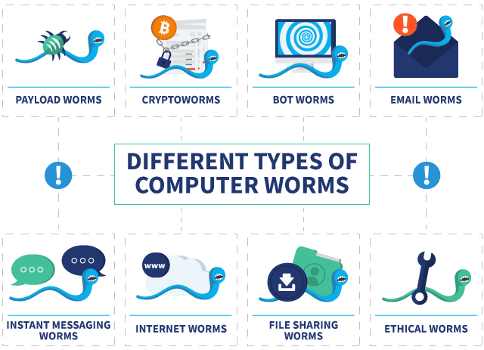
By definition, a computer worm is a type of malware. Its most distinct feature? Its ability to spread quickly without human interaction. It self-replicates once it gets into your computer, smartphone, or tablet, which is why it’s one of the scariest types of malware.
How Does a Computer Worm Work?
As a type of malware, computer worms can do various harmful things to your devices. Some simply self-replicate to the point that they eat up storage disk space and system memory, rendering your device unusable. Others modify or delete files, or even install additional malicious programs. And because computer worms can spread like wildfire, hackers may design them to install backdoor programs, giving cybercriminals access to their target’s devices.
How a Worm Spreads
A computer worm takes advantage of system vulnerabilities to accelerate its spread. It can jump from one device to another through different means, be that an email attachment, malicious link, or local area network (LAN). Here are the most common ways a computer worm spreads:
- The internet: Most devices connect to the internet via a network, which is a convenient superhighway for computer worms to spread. Once a worm infiltrates a device, it can spread to other devices throughout the LAN.
- Emails: Have you ever received a suspicious email with a link or an attachment from a stranger? That’s how some hackers spread malware, including worms. There are also worms that can make email programs such as Outlook send emails containing the malware to contacts autonomously.
- File-sharing platforms: Unless you know where it’s from, there’s really no way to tell if the file you’re downloading from a peer-to-peer file sharing platform contains malware. That’s why worms spread easily through such platforms.
- Instant messaging: Similar to malicious emails attachments, instant messages may be computer worms posing as harmless links or attachments.
- Smartphones: Smartphones are ideal worm carriers because we tend to connect our phones to multiple Wi-Fi networks, which could accelerate the spread of worms.
- Removable drives: A flash drive or a removable hard drive can get infected if plugged into an infected computer. Subsequently, infected removable drives can spread the worm when they are connected to different computers.
- Installer downloads: Looking to pirate a software program? Be careful – phishy websites may offer downloadable software installers that are actually malware.
- Torrent: You may think you’re downloading a pirated version of “The Avengers: Infinity War” (which is illegal, by the way), but it could actually contain a worm. The bottom line is, don’t pirate anything or use a VPN when torrenting non-copyrighted content.
- IoT devices: It’s scary to think that our smart home devices can turn against us, but according to researchers, the possibility is real. In a controlled environment, researchers were able to weaponize a single smart bulb to spread a computer worm to neighbouring Zigbee IoT devices.
Infamous Examples of Computer Worms
There have been many significant computer worm attacks in the past, and the scary thing is, some of them exist to this day. The My Doom worm, for instance, is still actively sending itself through email attachments 16 years after its creation; if it were a child, it would be driving by now! Here are several other computer worms that have caused significant damage in the past:
- Morris worm: The Morris worm was the first computer worm with real-world impact. A computer science student accidentally created the worm in 1988, which crashed many of the 6,000 computers it affected.
- WannaCry/Wanna Cryptor: The WannaCry worm encrypted files of Windows users in 2017 and asked for a ransom in exchange for their files. It was a worm that spread ransomware.
- ILOVEYOU/Love Bug/Love Letter worm: The ILOVEYOU worm spread through emails in 2000 posing as a love letter attachment. It infected over 10 million computers.
- Nimda: Nimda was the first computer worm that modified existing websites to offer malicious downloads.⁴ It spread by sending mass emails and then began propagating in LANs.
- Code Red: The Code Red worm initiated a DDoS attack (distributed denial of service) aimed at the U.S. White House using infected computers. This attack forced the White House and its web servers to change IP addresses.
- MSBlast/Blaster: Originally, the Blaster displayed two messages when executed: “I just want to say LOVE YOU SAN” and “billy gates why do you make this possible ? Stop making money and fix your software!!” However, it also forced computers to shut down as a side effect.
- Sobig worm: The Sobig worm had several versions, from Sobig.A to Sobig.F. It spread as an email attachment with common subject lines such as “Thank You” or “Re: Details.” Once it infected a computer, the worm searched for its next targets by sending 20 or more emails to the user’s contacts.
- Jerusalem/BlackBox worm: This was a type of worm that ate computer resources. When triggered, it deleted any program run on Friday the 13th of any year. It also infected .exe files repeatedly until they grew too large for the computer to handle.

KT0207 Phishing.
What is a phishing attack
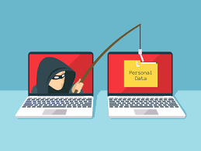
Phishing is a type of social engineering attack often used to steal user data, including login credentials and credit card numbers. It occurs when an attacker, masquerading as a trusted entity, dupes a victim into opening an email, instant message, or text message. The recipient is then tricked into clicking a malicious link, which can lead to the installation of malware, the freezing of the system as part of a ransomware attack or the revealing of sensitive information.
An attack can have devastating results. For individuals, this includes unauthorized purchases, the stealing of funds, or identify theft.
Moreover, phishing is often used to gain a foothold in corporate or governmental networks as a part of a larger attack, such as an advanced persistent threat (APT) event. In this latter scenario, employees are compromised in order to bypass security perimeters, distribute malware inside a closed environment, or gain privileged access to secured data.
An organization succumbing to such an attack typically sustains severe financial losses in addition to declining market share, reputation, and consumer trust. Depending on scope, a phishing attempt might escalate into a security incident from which a business will have a difficult time recovering.
Phishing attack examples
The following illustrates a common phishing scam attempt:
- A spoofed email ostensibly from myuniversity.edu is mass-distributed to as many faculty members as possible.
- The email claims that the user’s password is about to expire. Instructions are given to go to myuniversity.edu/renewal to renew their password within 24 hours.
Several things can occur by clicking the link. For example:
- The user is redirected to myuniversity.edurenewal.com, a bogus page appearing exactly like the real renewal page, where both new and existing passwords are requested. The attacker, monitoring the page, hijacks the original password to gain access to secured areas on the university network.
- The user is sent to the actual password renewal page. However, while being redirected, a malicious script activates in the background to hijack the user’s session cookie. This results in a reflected XSS attack, giving the perpetrator privileged access to the university network.

KT0208 Spear phishing.

Spear phishing targets a specific person or enterprise, as opposed to random application users. It’s a more in-depth version of phishing that requires special knowledge about an organization, including its power structure.
An attack might play out as follows:
- A perpetrator researches names of employees within an organization’s marketing department and gains access to the latest project invoices.
- Posing as the marketing director, the attacker emails a departmental project manager (PM) using a subject line that reads, Updated invoice for Q3 campaigns. The text, style, and included logo duplicate the organization’s standard email template.
- A link in the email redirects to a password-protected internal document, which is in actuality a spoofed version of a stolen invoice.
- The PM is requested to log in to view the document. The attacker steals his credentials, gaining full access to sensitive areas within the organization’s network.
By providing an attacker with valid login credentials, spear phishing is an effective method for executing the first stage of an APT.
How to prevent phishing
Phishing attack protection requires steps be taken by both users and enterprises.
For users, vigilance is key. A spoofed message often contains subtle mistakes that expose its true identity. These can include spelling mistakes or changes to domain names, as seen in the earlier URL example. Users should also stop and think about why they’re even receiving such an email.
For enterprises, a number of steps can be taken to mitigate both phishing and spear phishing attacks:
- Two-factor authentication (2FA) is the most effective method for countering phishing attacks, as it adds an extra verification layer when logging in to sensitive applications. 2FA relies on users having two things: something they know, such as a password and user name, and something they have, such as their smartphones. Even when employees are compromised, 2FA prevents the use of their compromised credentials, since these alone are insufficient to gain entry.
- In addition to using 2FA, organizations should enforce strict password management policies. For example, employees should be required to frequently change their passwords and to not be allowed to reuse a password for multiple applications.
- Educational campaigns can also help diminish the threat of phishing attacks by enforcing secure practices, such as not clicking on external email links.

KT0209 Insider security threats
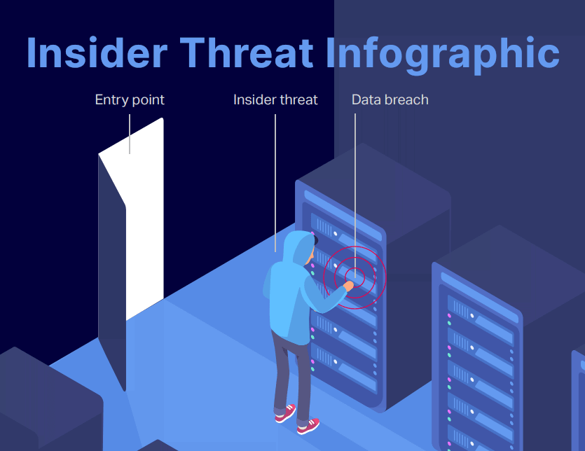
What is an insider threat?
An insider threat refers to a cyber security risk that originates from within an organization. It typically occurs when a current or former employee, contractor, vendor or partner with legitimate user credentials misuses their access to the detriment of the organization’s networks, systems and data. An insider threat may be executed intentionally or unintentionally. No matter the intent, the end result is compromised confidentiality, availability, and/or integrity of enterprise systems and data.
Insider threats are the cause of most data breaches. Traditional cybersecurity strategies, policies, procedures and systems often focus on external threats, leaving the organization vulnerable to attacks from within. Because the insider already has valid authorization to data and systems, it’s difficult for security professionals and applications to distinguish between normal and harmful activity.
Malicious insiders have a distinct advantage over other categories of malicious attackers because of their familiarity with enterprise systems, processes, procedures, policies and users. They are keenly aware of system versions and the vulnerabilities therein. Organizations must therefore tackle insider threats with at least as much rigor as they do external threats
Characteristics of an insider threat
- Involves someone with a degree of privileged access to or knowledge of an organization: Employees are common sources of insider threats, but contractors, vendors, interns, board members or anyone else with non-public levels of access are also insiders.
- Difficult to prevent: As the threat, by definition, comes from inside the organization, security controls focused on external actors will not apply. A firewall, for example, can’t stop an insider threat from accessing the company network, because he or she is already on the company network.
- Difficult to detect: Insiders require some level of privileged access to do their job, but it's often difficult for technology to discern exactly how an insider is using said access. A worker might download a document to review during a transatlantic flight, or they might download it to share with a competitor. Basic access control won’t be able to tell the difference between the two motives.
- Often has a strong motivation. In the case of a malicious insider threat, there is often a very strong motive. An employee who feels he or she was wrongly terminated, for example, may hold a grudge against the former organization. In the most extreme cases, those with an ideological motive may have nefarious intent in mind even when applying for a position at a company in the first place.
Who is at risk of insider threats?
While any organization is susceptible to an insider threat, certain industries tend to experience either more serious or more frequent incidents:
  - Healthcare: Verizon’s 2019 Insider Threat Report found that healthcare organizations were responsible for more reported insider attacks than any other industry. While some of this could be explained by the sector’s unique mandatory reporting requirements, other Verizon research revealed that healthcare was the only industry in which insiders were responsible for a larger share of breaches than external threat actors.
- Financial services: Research from the Ponemon Institute shows that the financial industry spends more than any other on containing, investigating and responding to insider threat risks. Interestingly, anecdotal evidence suggests many insider attacks in the finance industry are actually motivated by grudges.
- Manufacturing: The manufacturing sector has shown up as a particularly noteworthy victim in multiple studies and surveys of malicious insider threats. The proprietary knowledge that’s involved in a variety of critical manufacturing processes has proven particularly alluring to malicious insiders.
- Aerospace and defense: Critical sectors such as aerospace and defense account for some of the most damaging insider threat incidents. Economic espionage, advanced campaigns by nation-state actors, and politically motivated insiders have all played a role in past incidents.
- Government and academia: Organizations such as CISA, the National Institute of Standards and Technology, and the FBI have been particularly active in boosting insider threat awareness within the federal government during the last several years. Public entities of all sizes, however, still remain vulnerable to different types of insider threats.
The Ponemon Institute’s Research also shows that the frequency of insider threat incidents is directly related to an organization’s headcount and that organizations in North America appear to be the most frequently attacked victims.
Types of insider threats
There’s seemingly no end to the variety of ways a privileged insider could do damage — that’s what makes insider threat prevention so difficult. However, most insider threats can be categorized based on their intent:
Turn cloaks
Malicious insiders known as turn cloaks knowingly take action to harm an organization. The insider could be an employee, a contractor or even a trusted business partner. Turn cloaks could be motivated by financial gain, revenge or political ideology. Some perform covert actions such as stealing sensitive documents or proprietary information. Others prefer a path of destruction, wiping databases and leaving a trail of total chaos on their way out the door.
Pawns
In contrast to the turncoat, pawns don’t intend for their actions to have an adverse impact. Some pawns are simply careless, reusing passwords between work and personal accounts or leaving flash drives full of sensitive information at a coffee shop. Others may perform negligent or reckless actions such as circumventing security measures for their own personal convenience. Still, others are completely unwitting participants, falling for phishing scams or other forms of social engineering. Pawns can sometimes skirt the line with a turncoat by knowingly cooperating with an external party, but failing to realize the true implications of their actions.
Moles
Moles operate much like turn cloaks, but moles join a company intending to cause harm to the organization. They are very often driven by a strong political motive, whether to a nation-state or fringe cause. Moles are among the most difficult insider threats to detect and are potentially the most damaging.

Internal Assessment Criteria and Weight
- IAC0201Computer and network security threats and attacks are defined and how they work is explained.
- IAC0202 Potential solutions are identified.

KM-01-KT03: Identity theft
Topic elements to be covered include:
- KT0301Phishing scams,
- KT0302Malware,
- KT0303Social engineering,
- KT0304Financial frauds

KT0301 Phishing scams,
Scammers use email or text messages to try to steal your passwords, account numbers, or Social Security numbers. If they get that information, they could get access to your email, bank, or other accounts. Or they could sell your information to other scammers. Scammers launch thousands of phishing attacks like these every day — and they’re often successful.
Scammers often update their tactics to keep up with the latest news or trends, but here are some common tactics used in phishing emails or text messages:
Phishing emails and text messages often tell a story to trick you into clicking on a link or opening an attachment. You might get an unexpected email or text message that looks like it’s from a company you know or trust, like a bank or a credit card or utility company. Or maybe it’s from an online payment website or app. The message could be from a scammer, who might
- say they’ve noticed some suspicious activity or log-in attempts — they haven’t
- claim there’s a problem with your account or your payment information — there isn’t
- say you need to confirm some personal or financial information — you don’t
- include an invoice you don’t recognize — it’s fake
- want you to click on a link to make a payment — but the link has malware
- say you’re eligible to register for a government refund — it’s a scam
- offer a coupon for free stuff — it’s not real
Here’s a real-world example of a phishing email:
Image

Imagine you saw this in your inbox. At first glance, this email looks real, but it’s not. Scammers who send emails like this one are hoping you won’t notice it’s a fake.
Here are signs that this email is a scam, even though it looks like it comes from a company you know — and even uses the company’s logo in the header:
- The email has a generic greeting.
- The email says your account is on hold because of a billing problem.
- The email invites you to click on a link to update your payment details.
While real companies might communicate with you by email, legitimate companies won’t email or text with a link to update your payment information. Phishing emails can often have real consequences for people who give scammers their information, including identity theft. And they might harm the reputation of the companies they’re spoofing.
How To Protect Yourself From Phishing Attacks
Your email spam filters might keep many phishing emails out of your inbox. But scammers are always trying to outsmart spam filters, so extra layers of protection can help. Here are four ways to protect yourself from phishing attacks.
Four Ways To Protect Yourself From Phishing
1. Protect your computer by using security software. Set the software to update automatically so it will deal with any new security threats.
2. Protect your cell phone by setting software to update automatically. These updates could give you critical protection against security threats.
3. Protect your accounts by using multi-factor authentication. Some accounts offer extra security by requiring two or more credentials to log in to your account. This is called multi-factor authentication. The extra credentials you need to log in to your account fall into three categories:
- something you know — like a passcode, a PIN, or the answer to a security question.
- something you have — like a one-time verification passcode you get by text, email, or from an authenticator app; or a security key
- something you are — like a scan of your fingerprint, your retina, or your face
Multi-factor authentication makes it harder for scammers to log in to your accounts if they do get your username and password.
4. Protect your data by backing it up. Back up the data on your computer to an external hard drive or in the cloud. Back up the data on your phone, too.
What To Do if You Suspect a Phishing Attack
If you get an email or a text message that asks you to click on a link or open an attachment, answer this question:
Do I have an account with the company or know the person who contacted me?
If the answer is “No,” it could be a phishing scam. Go back and review the advice in How to recognize phishing and look for signs of a phishing scam. If you see them, report the message and then delete it.
If the answer is “Yes,” contact the company using a phone number or website you know is real — not the information in the email. Attachments and links might install harmful malware.

KT0302 Malware,
What is Identity Theft? Definition
A common identity theft meaning is when someone takes someone else’s personal information and then uses it for their own benefit, particularly without getting the individual’s permission. Identity theft can take many forms, and each one affects the victim in different ways. Regardless of how you define identity theft, in every instance, the target’s reputation, financial security, or financial future is put at risk.
Because there are so many ways someone can steal your identity, it is virtually impossible to prevent becoming a target altogether. Even if you do not have a lot of liquid assets, an impressive credit score, or access to valuable targets, such as people or secured systems, a thief can still make a profit off your identity.
In many cases, what happens after your identity has been stolen may have a minimal financial impact. However, a thief can make anywhere from a few to hundreds of dollars by selling your identity. Therefore, identity thieves typically go after anyone because each identity has an intrinsic value on the black market. In other situations, the thief aims to personally exploit your identity. If this is the case, they may be more surgical regarding who they choose to target.
In either case, you can minimize your chances of falling victim to identity thieves by learning how it happens, the different kinds of identity theft, signs you have been targeted, and how to protect yourself from these kinds of attacks.
How Identity Theft Happens
The term “identity theft” encompasses a broad range of methods of stealing other people’s information. However, it is common for a thief to target high-value information, such as a Social Security number, and use it to buy something, open an account, or commit fraud that involves impersonating the individual, particularly online.
There are several ways this happens.
Data Breaches
A data breach is when a thief or hacker is able to access the data of an organization without receiving the proper authorization. The company may have sensitive information stored in a central location. The thief targets the database or file holding that information and tries to penetrate any cyber defenses in place. In many cases, the thief will focus on getting credit card or Social Security numbers, as well as the complete names of the owners.
Files containing other information can be highly sought-after targets as well, particularly because that information can be used to correlate the identity of each person. For example, where the individual lives, has lived in the past, their phone number, old phone numbers, or maiden names can all be the targets of a data breach.
Unsecure Browsing
In most cases, the websites you visit are safe. They are protected by security measures that prevent hackers from gaining access to the information you enter. The protection often involves encrypting the data that gets entered. This way, if a thief were to intercept data, they would only get a jumbled arrangement of letters, numbers, and symbols instead of your Social Security number, name, address, etc.
However, if you use websites that are not as well-known, you may be putting yourself at risk. Even if the website’s designer had good intentions, the website itself may have been compromised by a hacker. In other cases, a hacker can design a fake website that looks like a real one. When you enter your information, it goes straight to the hacker instead of the company you thought you were sending it to.
Often, your browser can detect fraudulent websites and alert you to the danger. If you get an alert, it is best to take action by leaving the website and closing your browser.
Dark Web Marketplaces
The dark web consists of a network of websites hidden from regular internet users. When someone visits the dark web, they can use software to hide who they are, as well as what they are doing while connected. This makes the dark web an ideal place for thieves, hackers, and others looking to defraud users.
As a result, the dark web is a prime selling ground for your personal information. Hackers recognize the elevated risk associated with trying to exploit personal information themselves, so they often head to the dark web to sell it off to someone else. The initial buyer may use it or sell it to another malicious actor to make a quick profit. Therefore, if your information goes to the dark web, it is virtually impossible to say how it will be used.
Malware Activity
With malware, or malicious software, a hacker can accomplish any number of things—from taking over a computer system to controlling a network, to providing backdoor access and more. Malware can also be used specifically to steal personal information.
The most common way malware is used to execute identity theft or fraud is when it is programmed to spy on the target’s computer activity. The attack may begin with a phishing email or other trap designed to get the user to click on a link or image that automatically installs the malware.
An attack can be performed using a number of methods, such as keyloggers, which can keep track of which keys a user strikes. When the user accesses a particular website or logs in to their computer, the keylogger can record their keystrokes and report them back to the thief. In this way, the attacker can ascertain their password to a specific site, workstation, or application. Once the attacker uses that login information, they may be able to collect the target’s personal information.
Malware can also be used to provide backdoors for attackers who wish to gain access to a database or file that contains personal information. The malware, once installed, allows the hacker to get behind the system’s defenses. The hacker uses this avenue to penetrate the system and then glean the personal information of internal users or the company’s clients and customers.
Credit Card Theft
Credit card theft is one of the most simple ways a thief can steal your identity. Once they have access to your credit card, they often do not need any other aspect of your identity—the card itself is enough to make purchases under the target’s identity. A thief may even make relatively large purchases the user could not possibly pay off. They could then sell the item to someone else at a steep discount, banking a profit along the way.
Credit card theft can also be used to grab card numbers for resale on the dark web. A credit card number may go for a few dollars or far more. The thief gets your credit card information and then sells it to someone else. It is important to instantly cancel any credit cards that have been lost or stolen, but often, a data breach is used to get ahold of your card information.
Companies store long lists of credit card information to help their customers make quicker purchases. When the customer first does business with the company, the credit card information is obtained and kept in a secure location. When the customer returns, because their card information is already in the company’s system, their next purchase is quicker and easier. This convenience comes at a cost, however, because if someone is able to penetrate the defenses protecting customers’ card information, they can get a storehouse of account numbers.
Mail Theft
Even before the internet, identity thieves were busy taking people’s personal information and using it for their benefit. A common method was mail theft. In this kind of attack, the thief grabs the target’s credit card or other information from their mailbox. They then try to use it to make purchases—or sell it to another thief for a quick profit.
A thief does not have to go into your mailbox to take your credit card or gather personal information. It is just as easy to go through your trash. Often, people throw out letters, notices, or account statements that contain sensitive information. Even if the information in the trashed document is not enough to execute a complete theft of your identity, it can be used by the thief to confirm who you are. It is best to shred your old mail instead of just throwing it in the garbage.
Phishing and Spam Attacks
An attacker may send an email or text message that looks like it is coming from a legitimate source. When the target clicks on a link, they are taken to a fake website that asks you for your username, password, or other personal information like your Social Security or credit card number. The hacker can then use that information to assume your identity or make purchases.
Wi-Fi Hacking
Anytime you use your computer or mobile device on a public network, you may be vulnerable to a hacker that can eavesdrop on your communications with the network. This is a particularly prevalent issue at places like coffee shops, department stores, or airports where anybody can get onto the network, often without a password.
Once the hacker has started spying on your communications, they watch to see if you enter your personal information. They may specifically be after your Social Security, credit card, or bank account number. Once they have it, they can use it to make purchases, masquerade as you online while opening accounts, or sell the information to someone on the dark web.
Mobile Phone Theft
Some people use their mobile phones to log in to sites automatically, without having to enter their username or password. If someone gets a hold of your mobile phone, they may be able to access these same sites, especially if they do not need to enter a password or use biometric verification, such as a fingerprint or facial scan.
Mobile phone theft is also popular because people often store their personal information, including passwords and account numbers, in applications on their phones. This may include an app where you can manage and edit notes or email and text apps. If a thief can take your phone and get into it, they can easily navigate to your emails and text messages to steal information.
Further, if they want to execute a more sophisticated attack, they can use your phone to fulfil the second stage of a two-factor authentication (2FA) access procedure. When the site or application sends a text to you, the thief receives it and can then enter a verification number to gain access to the application or site.
Card Skimming
Credit card theft may also involve skimming. In a skimming attack, a fake credit card machine is installed on a gas pump or another point-of-sale (POS) device. It is then used to collect the card information of customers as they swipe their cards. A skimming attack often uses a hidden camera to record the target’s password, particularly if they are using a debit card.
It is important to keep an eye out for any credit card machine that looks out of the ordinary. For example, the card-swiping device may protrude excessively from the machine or the device may be loose when you shake it. If anything seems suspicious, stop using the machine, check around for small cameras pointed toward it, then alert the proper authorities. Letting them know the reasons why you suspected a skimming machine, as well as the exact location, can help them track down the perpetrator and protect your information and that of others.
Child ID Theft
With child ID theft, the child’s personal information is used to execute the attack. This may include the child’s Social Security number, which can be mailed to you soon after they are born. The attacker may not use the information for many years, waiting until the child is old enough to get a credit card. When they reach the right age, the thief then uses the information to open an account or obtain credit in the name of the child.
Tax ID Theft
With tax ID theft, the attacker uses your social security number and other necessary information to file taxes and then collect your refund. They may also alter the tax information they enter to inflate the refund they get. If this happens to you, there is a chance you will not know until you try to file your taxes. The Internal Revenue Service (IRS) will then alert you that someone has already filed a tax return in your name. After an investigation, you should be able to file your taxes and get the refund you are entitled to.
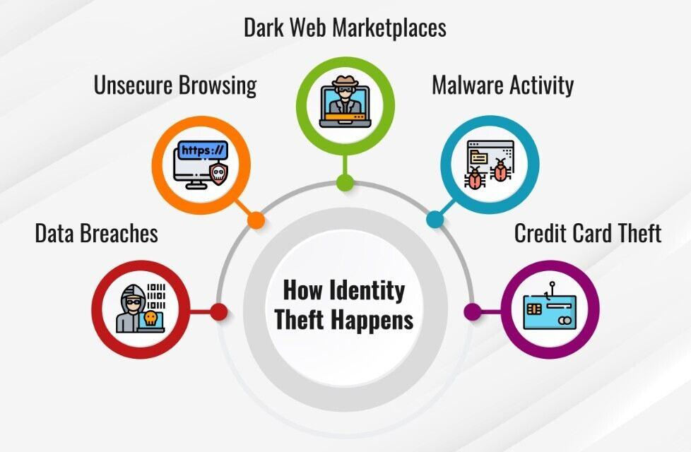
What is Identity Fraud?
Identity fraud and identity theft are similar, and the terms can sometimes be used interchangeably. However, identity fraud is different in that it specifically refers to using the stolen information, while identity theft may only involve stealing your personal information. There are several different types of identity fraud, including using a credit card, taxes, employment, phone or utility bills, bank account information, leases or loans, and government benefits or documents.
Regardless of the type of fraud, the execution of the attack is similar: The thief uses account numbers, Social Security numbers, and other personal information to make another entity believe they are you. They then use that to make or take money.
Effects of Identity Theft
There are several ways identity thieves can use your personal information to their advantage. Some involve using it to steal money from you, while others require multiple steps before the thief realizes a profit.
Stolen Money or Benefits
A criminal can use your credit card number, address, and name to buy things with your card. They can also file a tax return or even use your insurance and other information to get medical treatment while pretending to be you. If you have airline miles or can get access to government services like the Special Supplemental Nutrition Program for Women, Infants, and Children (WIC) or Social Security checks, the thief could use your information to take advantage of those provisions as well.
Identity Sold on the Dark Web
Once your data has been taken, particularly during a data breach where the thief can grab many victims' information at once, it may be sold on the dark web. Even though each piece of information may only yield a few dollars, if a thief has thousands of account numbers, addresses, and names, their profits can add up quickly.
Impersonation
A thief may pretend to be you on social media or to get a job or apartment. This is particularly true when there is an element of their own identity that gets in the way of what they are trying to do, such as a criminal record.

KT0303 Social engineering,

What is Social Engineering Identity Theft?
In identity theft terms, ‘social engineering’ is the act of influencing one to become an identity theft victim through social tactics. Though complex methods are used, the goal remains the same; the identity thief tries to trick you into giving up sensitive information about yourself.
There are few limits to how an identity thief might try to fool you into giving up the goods. They could call you impersonating your credit card provider, your doctor, or another business or entity. You could get a message from your best friend’s hacked Facebook, sending you to a phishing website. Regardless, knowing about each of these types of tricks will help you to know what to trust and avoid in the future.
Types of Social Engineering Tactics
There are endless ways an identity thief could use social engineering to steal your personal information. The list below is just a scratch at the surface, but it covers the most common tactics used.
Card Skimming
You walk into a random bank in Venezuela and pop in your debit card. If it fails to come back out, there might be a card stealer in the machine. If the entire transaction works, a camera and keypad reader could capture enough details to replicate the card for fraud. Of course, almost the whole world is aware of the potential risks of ATM skimming by now.
Now, imagine if your identity was stolen after buying Christmas gifts at Walmart. It’s a big-box store, so you might assume using your credit card there is safe — as did the 80 million victims of the Target data breach. Of course, the signs should have been there — even back in 2007. There were 40 million Americans who had their payment information exposed after shopping at T.J. Maxx.
The problem is that you never know when a cashier is really skimming your credit card information. This is even more concerning when paying at a restaurant, where your server might take your credit card out of sight for a few minutes.
You cannot guarantee that a card skimming trick will not affect you. Yet, the social engineering aspect factors profiling customers to see who is worth making a victim. These fraudsters do not just steal every customer’s identity that interacts with them, as they would end up with the blame.
You might want to keep your high-dollar purchases off your credit cards. It would be a good idea to choose which credit card to use by payment size. As in, use your credit card with a $500 limit to pay for a $25 purchase instead of your $50,000 business card. If the cashier cannot profile the target personally, they will base their choice of a victim on the apparent value — this is determined by the type of card, such as by looking for terms like Business and Gold on the card name.
Dumpster Diving
Put yourself in the shoes of Tom Cruise between being crazy and rich. You have little time left to take out the garbage. As such, you might have a cleaning crew that comes in to dispose of the trash for you. As a random stranger walks by, watching the cleaner put the trash out, they have an epiphany. The trash ‘must’ have sensitive information about this famous homeowner, so they dig in the trash.
An identity thief can ‘hop in a dumpster’ and ‘pull out an identity’ in most cases. But, sometimes, the criminal might find a bunch of shredded paper instead. The ‘social engineering’ identity thief will go a step further and apply for a cleaning service job. From there, they have access to the inside of the home, where the sensitive documents have yet to be shredded.
In any event, the only way to prevent dumpster diving is to manage the security of your paperwork yourself. You would have to avoid using cleaning services. The same is true for any other service providers home-based, especially those that work outside of your supervision. Of course, everyone should follow the basic rule of thumb and shred any papers containing sensitive information when they are no longer needed.
Fake Employment
While looking for a new job, you stumble upon an ad that sounds perfect. The pay is right, the job duties are simple enough, and you possess the one skill they truly need in an employee. The obvious thing to do is send your resume and hope that you get an interview. If you do, it’s all happiness and high-nerves from there, so letting some personal information slip when you think you ‘got the job’ is understandable.
Except, it’s not always an actual employer (or recruiter) on the other side of the screen. Sometimes it’s just an identity thief running an elaborate social engineering ploy. This is why you need to be very careful about who gets your resume; after all, it immediately gives away a lot of information about you. The sad part, you can find thousands of real people’s resumes on Google Images by playing around with your search terms a bit.
Similar to fake employment, you could also find this approach used with fake loan offers. These are tailored towards those experiencing financial distress, as they are the most vulnerable individuals. They are made to believe that they will qualify for the loan they need, so long as they can verify their identity first.
The information that’s gathered could be obtained personally or through a honey-pot website built for the scam. The latter is more convincing, while the former is easy to spot after all, what legitimate lender searches for borrowers through Yahoo Answers?
Ghosting
Ghosting is a term used to describe the act of stealing the identity of someone who is already deceased. This tactic is used because there is no victim around to report the crime. Most ghosting identity theft cases go unnoticed for many years, and some never get caught as the ‘victim’ has no surviving family to look out for them.
The problem is that the borrower might be dead, but their Social Security Number is still active. This means the person’s identity could get used to rack up new debt. If the individual has not ever had an open credit report, it becomes much easier as the fraudster can defraud the deceased victim through synthetic identity theft techniques.
Most identity thieves strike this way after first finding their deceased targets. This often starts with a scan of the obituaries or by pressing for information through the funeral home. An identity thief might be able to start up a conversation, in person or by phone, to get the information they need.
Either way, many funeral homes do not handle sensitive information about their clients as well as they should, and it just takes one loophole for an identity thief to stumble upon a gold mine. The attacker might need to catch the details in the first few days after the victim’s death. If a family member is left in charge, they will be responsible for requesting a ‘deceased’ note on their relative’s credit report.
Hacking
Hacking is an identity theft subject that could run on for years. This is because the hacking approach opens the doors to many different opportunities. An identity thief could hack into their target’s accounts to steal information, which is later used to defraud them. They can also hack into a website and breach their security to gain information about many potential victims.
Regardless of the hacker’s target, the goal is always to obtain sensitive information about them. This is done through the Internet, where many cybercriminals have joined together to work better. A lot of personal information exposed through major hacks is later leaked in these hacker-based Web communities. It could be given for free or sold at a small cost to another criminal looking to commit identity fraud.
It just takes a single instance of having your information exposed to a hacker for you to become an identity theft victim. You never know when they will attack, so you need to leave as little trace as possible.
For example, most people do not delete their Facebook messages very often. Ask yourself now if your Facebook gets compromised, would there be any messages (now or years ago) that mention your address, credit card details, or any other sensitive information? What about your e-mail account? Do you have any old messages that will help hackers steal other accounts, leading to sensitive data?
As long as a hacker lacks the will to quit, there will always be the possibility that a hacker gets your information and steals your identity.
Pharming
Pharming is the same as phishing, except it gets kicked up a couple of notches. In most cases, it involves the same tactic of sticking links to phishing websites in email messages. The attacker might even go as far as to compromise an e-mail account and then forward the phishing page to their peers. The landing page appears as it normally would, and the domain URL even reads right, but the IP behind it is different.
A computer could be redirected to the phishing page when the user types a specific URL in another type of pharming attack. This way, the victim went to the right domain, but a fraudulent IP backs the website. The same results as you would expect from a real phishing scam happen, the visitor enters their login credentials, and the attacker records them.
Pharming is a technique that is most commonly used to break into financial accounts. This method involves creating a fake landing page and coding it to record specific information that visitors enter. Some examples of websites that could get used in pharming scams include popular online banking sites and your PayPal log-in.
Phishing
Phishing is the process of luring an Internet user to a fraudulent website, where their keystrokes get tracked and recorded. This is a method that most are aware of now, as almost everyone has received a phishing attack at one point. In fact, thousands of phishing sites have been set up over the years to steal user credentials for various websites, such as eBay, Facebook, and PayPal.
Anything can get phished, so long as you are gullible enough to trust the landing page. Though, it is getting harder to fool people as they are becoming more aware of these schemes. Corporate level employees used to be easily phished, but now fraudsters take a new approach.
Phishing could be just a part of the scam; if the fraud can phish an e-mail account in a trusted network, much more damage could follow. The phishing tactic could get used to steal the log-in or steal more information from that person’s connections. Or, the e-mail account could get phished for the purpose of ‘pharming’ to steal sensitive information from people in the victim’s circle.
By now, you should know how phishing works. You are directed to a website disguised to be that of a legitimate company or service. The actual page is just a mask, and the information captured is later used by the attacker to commit fraud.
There are countless examples of phishing attacks that have happened over the years. For the most part, they can be classified into one of the three following groups:
- Attacks deployed through email.
- Forging the legitimacy of a website.
- Running a ‘man in the middle’ style attack.
Sometimes an attack will fall under more than one group. For instance, a phishing attack could be made through an e-mail to those who already installed browser exploits. The exploits will make the landing page appear even more trusted, as it forges authenticity; by combining the two, it’s a lot harder for the average Joe to pick up on the con.
A complex phishing attack paired with ‘pharming’ techniques is how employees of large corporations often end up with their e-mail accounts hacked and their company’s website servers compromised.
Smishing
Smishing is the act of ‘phishing’ for information by SMS message. The sender on the other end of the text message is merely a criminal. They often impersonate a business or entity that the potential victim knows or has an account with. The message is written in such a way that it builds anxiety, and in most cases, leads to the recipient clicking a hyperlink and landing on a phishing website.
Some common Smishing message tactics include:
- Pretending unauthorized charges were made on the victim’s account.
- Suggesting a reason for shock, such as, “Look at this image of you online.”
- Acting like the victim won a prize or is entitled to something.
- Spoofing a trusted phone number to ask the victim directly for sensitive information.
It’s easy to stay safe from smishing scams because most are obvious from the get-go. Few trusted businesses contact through text messages, and no sensitive information is ever requested from you this way. Further, you can examine the URL of the link in the text message for any signs of suspicion. Worst case scenario, enter the exact URL into the address bar of your computer to make sure it’s legitimate.
Vishing
Vishing is the act of ‘phishing’ for information over the phone. The voice on the other end is nothing more than that of a criminal. In most cases, they impersonate a business or entity that you trust — such as your bank or credit card provider. You are sold on a story that is actually believable to build rapport; in the end, the person on the phone is just trying to guide you into giving up a specific piece of information.
Here’s an example of a vishing phone call:
Fraudster: “Hello, this is Cindy from ‘Credit Card Company’ calling. We are reaching out in regards to a suspicious transaction that just showed up on your account. We see you are from ‘Your State’ and used your card recently, but this new transaction is on the other side of the country. Did you authorize a payment at ‘Business Name’ in ‘Another State’ this morning?”
As the cardholder is oblivious to the transaction, their obvious response is as follows:
Victim: “Of course not. There’s no way I managed to fly across the country while I was sleeping! The last transaction I authorized was on ‘Previous Date’ at ‘Name of Retailer’ as far as I can remember.”
Fraudster: “No worries, by law you are not held liable if any unauthorized charges were made. We will flag your account for now — any new transactions or changes to your account will trigger a verification call to this number. Now, to unlock your account and allow you to use your card with us again, I need to verify your identity.”
This is when you might get a little suspicious, but even legitimate entities might indeed need information about you at times. The appropriate thing to do is to request that you call them back at their extension number before providing sensitive information. If you fail to do so, you might fall for the scam.
Victim: “Sure, what do you need to know?”
Fraudster: “Alright, so we see that you have a ‘Credit Card Company Name’ credit card, issued by ‘Issuing Bank Name,’ and we have you listed as the sole cardholder. To verify your identity, we need to confirm a few details about you. First, would I be able to get your Date of Birth?” … and you know where that leads!

KT0304 Financial frauds
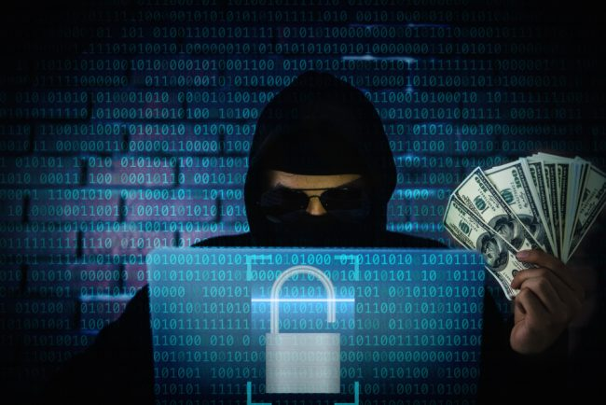
Financial identity theft
Financial identity theft is when one person uses another’s personal data for financial benefit. This is the most common form of identity theft (including the credit card example described above). Financial identity theft can take multiple forms, including:
- Fraudsters may use your credit card information to buy things. We all love to shop online — even criminals. Unfortunately, this issue has become especially prevalent thanks to online shopping during the COVID-19 pandemic.
- Hackers may steal funds from your bank account. Sometimes, the amount might be so small that it seems inconsequential, totaling just a few dollars. However, criminals can rack up millions in damages if they target enough people in this way.
- Criminals may open new accounts using your Social Security number and other data. For example, a person may use your data to open a new line of credit. They then run through the credit line, leaving you to foot the bill.
The good news is that it’s easy to protect yourself against financial identity theft by checking your bank accounts, credit card statements, and bills. If you see an unexplained charge, contact your credit card company or bank immediately to report it. Also, check your credit report for changes in your score. An unexplained decrease in your score could mean fraudulent activity.
Another idea is to place a one-year fraud alert on your credit reports to keep people from opening new accounts in your name. This encourages creditors and lenders to take extra precautions to verify your identity before granting any loans or credit increases. You can also place a security freeze on your credit report, which blocks others from accessing it to extend credit.
Medical identity theft
This might not seem like a real form of identity theft, but it happens. Medical identity theft is when a criminal poses as another person to obtain health care services. In fact, fraudsters may use your name and insurance information to:
- Get prescriptions for drugs.
- Access medical services, from checkups to costly surgeries.
- Obtain medical devices and supplies, such as wheelchairs or hearing aids.
This can result in you having bills for prescriptions, services, or devices you didn’t need, ask for, or even receive. Your health care and insurance records may even have these things added to them. An inaccurate medical record can make it harder for you to get the care you need in the future and even impact insurance coverage.
Fortunately, you can help minimize the risk of medical identity theft by regularly reviewing your medical claims. Contact your insurer if you see unfamiliar procedures, prescriptions, or services. You’ll also want to let your health care provider know so that they can ensure your medical files are correct.
Criminal identity theft
Criminal identity theft occurs when a person arrested by law enforcement uses someone else’s name instead of providing theirs. They might be able to pass this off by creating a fake ID or using a stolen ID, like your driver’s license, to show to the police. This type of fraud can be difficult to detect until the consequences are evident, like:
- You receive a court summons. For example, the courts may issue a summons if a criminal uses your ID for unpaid parking tickets.
- A bench warrant is issued for your arrest. Unresolved problems like unpaid parking tickets can also result in a judge issuing a bench warrant. You may then be taken into custody at any time, even during a routine traffic stop.
- A background check is issued. Sometimes, police will keep an identity theft victim in their database, noting it as an alias for the real criminal. This can result in a false criminal record showing up on your background check. This can cause problems with potential landlords and employers.
You can help protect yourself against criminal identity theft by safeguarding your ID. If your license or state-issued ID is lost or stolen, report it to the local Department of Motor Vehicles (DMV) and law enforcement. Also, limit the information you share online (and encourage family members to do the same). For example, if your teen got their first driver’s license and wants to share a pic of it on social media, explain why this isn’t a good idea.
Synthetic identity theft
As one of the fastest-growing types of financial crime in the U.S., synthetic identity theft involves creating fake identities using real people’s information. Fraudsters may use data like birthdates, addresses, and Social Security numbers from real people, blending them to create a fake profile. They can then use this persona to apply for loans or credit cards or commit other financial crimes. Kids and older adults tend to be vulnerable to this type of fraud since they rarely use their SSNs.
The most important thing about synthetic identity theft is knowing the signs and acting fast. Keep an eye out for any mail with your address on it but addressed to a different name and phone calls or mail about new credit accounts. You can further protect yourself by regularly checking your credit reports for unexplained changes and placing a security freeze on them.
There are also identity monitoring services available, which scan the internet, including the dark web, for breached Social Security numbers. If you suspect you or a loved one is the victim of synthetic identity theft, contact the relevant financial institutions to alert them.
Child identity theft
We all want to protect our children from bad actors, especially when it comes to identity theft. Child identity theft involves using a minor’s information to commit financial fraud, like opening a new account or line of credit under the child’s name. The thief may even use the child’s identity to get a driver’s license, apply for government benefits, or buy a house. This is often easier than targeting an adult because most kids don’t have credit reports or financial accounts, making them a clean slate.
Unfortunately, child identity theft is often perpetrated within the family by a relative who has access to the child’s data like their birthdate and address. And many children don’t realize they’ve been targeted until they’re older — for example, when they try to take out a student loan. By this point, the issue may have been escalating for years. So, it’s important as a parent to be aware of child identity theft.
The best way to do this is to check whether your child has a credit report with any of the three big credit bureaus (TransUnion, Equifax, and Experian). If so, review the report and report any fraudulent activity. You can also place a freeze on your child’s credit report to help minimize the risk of future fraud.
How do you know if you’re a victim of identity theft?
No one wants to be left in the dark when it comes to identity theft, so knowing the signs can help you spot it and take action quickly. This can help stop fraud in its tracks, minimizing both immediate damage and long-term repercussions. Some warning signs that may indicate identity theft include:
- You get a fraud alert from a financial institution. To protect customers against identity thieves’ scams, most banks have security protocols to pinpoint potential data breaches. For example, if you live in the U.S., but a purchase is made using your credit card information in London, your bank may stop the transaction and send you a credit card fraud alert.
- There are unexplained changes in your credit score. Your credit score going up can mean someone is trying to extend credit in your name (with the intent to run through it). A dip in your score could indicate anything from a loan application to a bill going to collection.
- There are changes to your financial accounts. Check your bank statements at least once a month, keeping an eye out for unfamiliar transactions or withdrawals. Also, check for an increase in your line of credit or a new credit card account (which someone else may have requested in your name).
- A loan or credit card application is denied. If you apply for a new credit card or a loan and are turned down, find out why. If you thought you had good credit, double-check your current credit history. Identity theft can result in your credit score
- You get phone calls from debt collectors. If collection agencies start calling you about unfamiliar debts, someone else might be using your information to open financial accounts or take out lines of credit. Don’t divulge any personal information on the phone but do check your credit report to see what debts they’re referring to.
- You get unfamiliar mail. If you get mail sent to your address that’s clearly for someone else, that person might be using your address for personal gain. Be wary if you receive medical bills in the mail that you don’t recognize or W-2 forms for companies you’ve never worked for.
- You experience tax return If you get a tax transcript you didn’t ask for, or the Internal Revenue Service (IRS) rejects your e-filing, identity theft might be to blame. Some thieves will file fraudulent returns to get the victim’s refund

Internal Assessment Criteria and Weight
- IAC0301An understanding of types of identity theft and how to mitigate them is demonstrated

KM-01-KT04: Adopting good cybersecurity practices
Topic elements to be covered include:
- KT0401Use of registered software
- KT0402Update software when they become old to newer versions which tend to have more security upgrades
- KT0403Encrypt data
- KT0404Use strong authentication (passwords and credentials) for all accounts
- KT0405Change passwords often and make sure they are strong and not easy to guess
- KT0406Data backup.

KT0401 Use of registered software
Technology used to be expensive and time-consuming to implement and many event organizers chose not to embrace technology because of this. This is not the case anymore and there are many cloud-based solutions from which to choose with various different pricing options. I believe there is a real risk for event organizers of becoming uncompetitive and having dissatisfied attendees if they choose to ignore the trends in technology.
Online registration software should not just improve the user experience, but also make life easier for the organizer. The advantages of having an online registration facility are:
(1) increase attendance
The speed and convenience of an online registration facility makes it more likely for participants to take action than having to go through a fax, post or phone registration process. Online payment and automated email reminders also makes it more likely for participants to commit to attending the event.
(2) increase revenue
Because of increased attendance and the 24 hour availability, convenience and speed of secure credit card payments, you would have access to funds much sooner than traditional methods.
(3) save time and money
Online registration and participant management functionality dramatically reduces the time spent on managing an event by reducing or eliminating the need for manual registration entry, invoices & receipts, email & telephone communication, printing, and manually compiling reports. Having a payment facility also further reduces time spent on tracking participants and it is possible to issue refunds through the system.
(4) help eliminate errors
The manual process of keying in information, communicating with participants and compiling documents increases the risk of errors that can lead to dissatisfied clients.
(5) real time information
Whenever you need to make changes to your program, pricing and other information, you can easily update this online and it would immediately reflect on the system. You will also have real time information at your fingertips like specific event attendance figures, outstanding payments and be able to control how many participants may register for a particular item. Most systems also allow you to export data to a spreadsheet application like MS Excel.
(6) customer satisfaction
A professional looking event website and an easy registration & payment process makes it more likely that you would get repeat customers and referrals.

KT0402 Update software when they become old to newer versions which tend to have more security upgrades
It always feels like new updates come at the most inconvenient times. The easiest option is normally to ignore.
Of course, they can be annoying but they aren’t just there for the fun of it. Turns out there’s a lot of good reasons to not put off software updates. They’re mostly free so you don’t have to worry about cost, you just have to set aside the time to do it.
With more and more people using cloud-based software, updates are regularly delivered to your computer, ready for you to install.
It’s also important to make sure non-cloud-based software is updated to the latest version or edition. Not least because you don’t tend to get reminders for these.
Below, we’ve got 4 of the big reasons why you should always keep your software up to date. If you would like some further assistance, our software consultancy team are always on hand to help too.

Better software
One reason to update to the latest version or a new edition is simply that you, the user, get a better program.
Software companies are constantly improving their products. Adding new features, improving the user journey and sharpening the functionality so that it achieves its end goal in the most efficient way possible.
The barrier to this of course is that you can get used to how a certain version of a program works. It can be hard to move on from something you’re used to.
But the chances are the new one is probably going to be better. Although initially it may seem illogical to start using something totally new, it’s probably for the best in the long run.
It doesn’t always work like that but generally it’s worth trusting that software developers are trying to do a good job and develop something that works better.

Fix bugs
Those pesky bugs. Not the creepy crawly variety but the little niggles and problems that are often found in software of any kind.
Most bugs you’ll never even notice but the reality is they’ve all got them.
It’s virtually impossible to release a 100% perfectly working product in time for launch so most of the time, the software will be released and then patched up later.
In some cases, one small bug can have a ripple effect causing a slew of related issues.
The good news is developers are always aiming to improve and fix flaws. In order to iron out the issues and have as smoothly running system as you can, it’s important to update and add those all-important bug fixes.

Improve security
One of the most important reasons for updating is to iron out security issues. If you are wanting to keep your business data really secure then an offsite backup solution is the best answer.
Hackers can become aware of vulnerabilities in certain software, sometimes caused by bugs and these can be exploited to harm your computer system and steal personal data. Old versions of software can become gateways into your network for hackers.
The software manufacturers soon become aware of these vulnerabilities and will patch up the weak or exposed areas… if you let them.
The good news is that it’s in their interest to make sure you’re safe and secure. They’d have a dumpster fire on their hands, if thousands of user’s data was leaked as a result of flaws in their programs.
Make sure you’re not needlessly creating a weak link in your armoury and instead keep all your software up to date for added business security.
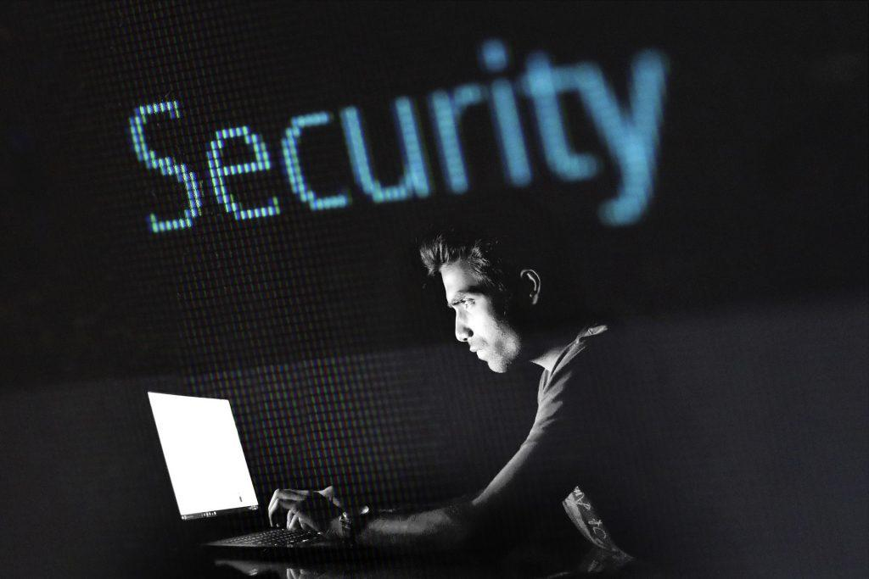
Improve performance
Old tired software can often eat up more computing power than it needs to. If it’s picked up a lot of extra weight in the time you’ve been using it or is just not running like it used to, then it would definitely be worth getting the latest version.
This will be optimised for your current operating system and should run fresh as a daisy. If it’s hosted via the cloud, a lot of the program won’t be using your servers so will also run faster as a result.

How do i know when something needs updating?
It might seem like a silly question to some, but it’s worth making sure you know exactly how to get the latest version of the software you’re using.
If the software is hosted in the cloud, then it will give you reminders, pretty regularly! And often the longer you put it off the more persistent they will become. But when the updates are free, why not dive in. Most small updates don’t take long to download.
If it’s not cloud-based then you won’t necessarily get these reminders although your business will probably receive information about the latest versions.
The most obvious way to know when it’s really time to make a change is with end of life announcements. When a software company announces they are ending support for a certain piece of software, either because it’s been replaced with their current output or because it’s broken, it’s usually time to move on.
Once that happens you will have no support for that program and it will be too risky to use.
In case you weren’t aware, at Reality Solutions our team can provide IT support services and guidance to you and your business, ensuring that you always have the latest updates for your software!
We can offer patch management solutions to all our customers ensuring that software is always kept up to date!
Additionally, our Technical Support team are always on hand to deliver advice to all our customers on updating software and providing guidance on migrating away from outdated legacy systems.

KT0403 Encrypt data

A Definition of Data Encryption
Data encryption translates data into another form, or code, so that only people with access to a secret key (formally called a decryption key) or password can read it. Encrypted data is commonly referred to as ciphertext, while unencrypted data is called plaintext. Currently, encryption is one of the most popular and effective data security methods used by organizations. Two main types of data encryption exist - asymmetric encryption, also known as public-key encryption, and symmetric encryption.
The Primary Function of Data Encryption
The purpose of data encryption is to protect digital data confidentiality as it is stored on computer systems and transmitted using the internet or other computer networks. The outdated data encryption standard (DES) has been replaced by modern encryption algorithms that play a critical role in the security of IT systems and communications.
These algorithms provide confidentiality and drive key security initiatives including authentication, integrity, and non-repudiation. Authentication allows for the verification of a message’s origin, and integrity provides proof that a message’s contents have not changed since it was sent. Additionally, non-repudiation ensures that a message sender cannot deny sending the message.
How Does Encryption Work
Data, or plaintext, is encrypted with an encryption algorithm and an encryption key. The process results in ciphertext, which only can be viewed in its original form if it is decrypted with the correct key.
Types of encryption
Symmetric-key ciphers use the same secret key for encrypting and decrypting a message or file. While symmetric-key encryption is much faster than asymmetric encryption, the sender must exchange the encryption key with the recipient before he can decrypt it. As companies find themselves needing to securely distribute and manage huge quantities of keys, most data encryption services have adapted and use an asymmetric algorithm to exchange the secret key after using a symmetric algorithm to encrypt data.
On the other hand, asymmetric cryptography, sometimes referred to as public-key cryptography, uses two different keys, one public and one private. The public key, as it is named, may be shared with everyone, but the private key must be protected. The Rivest-Sharmir-Adleman (RSA) algorithm is a cryptosystem for public-key encryption that is widely used to secure sensitive data, especially when it is sent over an insecure network like the internet. The RSA algorithm’s popularity comes from the fact that both the public and private keys can encrypt a message to assure the confidentiality, integrity, authenticity, and non-repudiability of electronic communications and data through the use of digital signatures.
Challenges to Contemporary Encryption
The most basic method of attack on encryption today is brute force, or trying random keys until the right one is found. Of course, the length of the key determines the possible number of keys and affects the plausibility of this type of attack. It is important to keep in mind that encryption strength is directly proportional to key size, but as the key size increases so do the number of resources required to perform the computation.
Alternative methods of breaking a cipher include side-channel attacks and cryptanalysis. Side-channel attacks go after the implementation of the cipher, rather than the actual cipher itself. These attacks tend to succeed if there is an error in system design or execution. Likewise, cryptanalysis means finding a weakness in the cipher and exploiting it. Cryptanalysis is more likely to occur when there is a flaw in the cipher itself.
Data Encryption Solutions
Data protection solutions for data encryption can provide encryption of devices, email, and data itself. In many cases, these encryption functionalities are also met with control capabilities for devices, email, and data. Companies and organizations face the challenge of protecting data and preventing data loss as employees use external devices, removable media, and web applications more often as a part of their daily business procedures. Sensitive data may no longer be under the company’s control and protection as employees copy data to removable devices or upload it to the cloud. As a result, the best data loss prevention solutions prevent data theft and the introduction of malware from removable and external devices as well as web and cloud applications. In order to do so, they must also ensure that devices and applications are used properly and that data is secured by auto-encryption even after it leaves the organization.
As we mentioned, email control and encryption is another critical component of a data loss prevention solution. Secure, encrypted email is the only answer for regulatory compliance, a remote workforce, BYOD, and project outsourcing. Premier data loss prevention solutions allow your employees to continue to work and collaborate through email while the software and tools proactively tag, classify, and encrypt sensitive data in emails and attachments. The best data loss prevention solutions automatically warn, block, and encrypt sensitive information based on message content and context, such as user, data class, and recipient.
While data encryption may seem like a daunting, complicated process, data loss prevention software handles it reliably every day. Data encryption does not have to be something your organization tries to solve on its own. Choose a top data loss prevention software that offers data encryption with device, email, and application control and rest assured that your data is safe.

KT0404 Use strong authentication (passwords and credentials) for all accounts
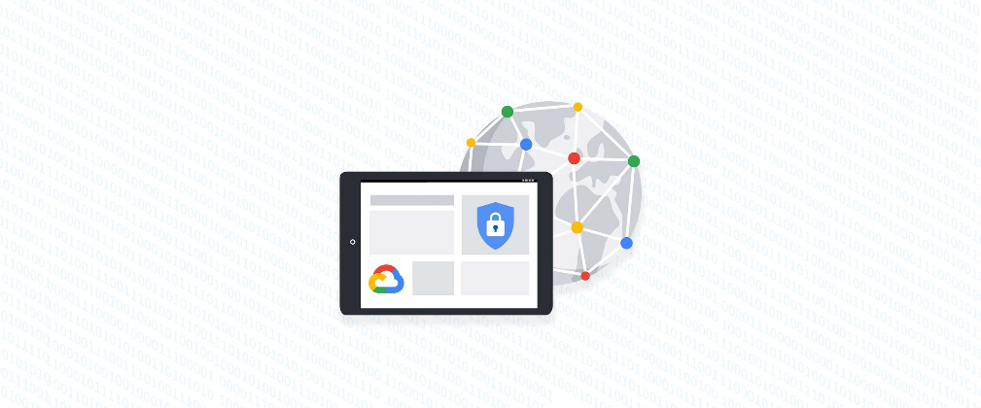
Account management, authentication and password management can be tricky. Often, account management is a dark corner that isn't a top priority for developers or product managers. The resulting experience often falls short of what some of your users would expect for data security and user experience.
Fortunately, Google Cloud brings several tools to help you make good decisions around the creation, secure handling and authentication of user accounts (in this context, anyone who identifies themselves to your system—customers or internal users). Whether you're responsible for a website hosted in Google Kubernetes Engine, an API on Apigee, an app using Firebase, or other service with authenticated users, this post lays out the best practices to follow to ensure you have a safe, scalable, usable account authentication system.
Hash those passwords
My most important rule for account management is to safely store sensitive user information, including their password. You must treat this data as sacred and handle it appropriately.
Do not store plaintext passwords under any circumstances. Your service should instead store a cryptographically strong hash of the password that cannot be reversed—created with Argon2id, or Scrypt. The hash should be salted with a value unique to that specific login credential. Do not use deprecated hashing technologies such as MD5, SHA1 and under no circumstances should you use reversible encryption or try to invent your own hashing algorithm. Use a pepper that is not stored in the database to further protect the data in case of a breach. Consider the advantages of iteratively re-hashing the password multiple times.
Design your system assuming it will be compromised eventually. Ask yourself "If my database were exfiltrated today, would my users' safety and security be in peril on my service or other services they use?” As well as “What can we do to mitigate the potential for damage in the event of a leak?"
Another point: If you could possibly produce a user's password in plaintext at any time outside of immediately after them providing it to you, there's a problem with your implementation.
If your system requires detection of near-duplicate passwords, such as changing "Password" to "pAssword1", save the hashes of common variants you wish to ban with all letters normalized and converted to lowercase. This can be done when a password is created or upon successful login for pre-existing accounts. When the user creates a new password, generate the same type of variants and compare the hashes to those from the previous passwords. Use the same level of hashing security as with the actual password.
Allow for third-party identity providers if possible
Third-party identity providers enable you to rely on a trusted external service to authenticate a user's identity. Google, Facebook, and Twitter are commonly used providers.
You can implement external identity providers alongside your existing internal authentication system using a platform such as Identity Platform. There are a number of benefits that come with Identity Platform, including simpler administration, a smaller attack surface, and a multi-platform SDK. We'll touch on more benefits throughout this list.
Separate the concept of user identity and user account
Your users are not an email address. They're not a phone number. They're not even a unique username. Any of these authentication factors should be mutable without changing the content or personally identifiable information (PII) in the account. Your users are the multi-dimensional culmination of their unique, personalized data and experience within your service, not the sum of their credentials. A well-designed user management system has low coupling and high cohesion between different parts of a user's profile.
Keeping the concepts of user account and credentials separate will greatly simplify the process of implementing third-party identity providers, allowing users to change their username, and linking multiple identities to a single user account. In practical terms, it may be helpful to have an abstract internal global identifier for every user and associate their profile and one or more sets of authentication datavia that ID as opposed to piling it all in a single record.
Allow multiple identities to link to a single user account
A user who authenticates to your service using their username and password one week might choose Google Sign-In the next without understanding that this could create a duplicate account. Similarly, a user may have very good reason to link multiple email addresses to your service. If you’ve properly separated user identity and authentication, it will be a simple process to link several authentication methods to a single user.
Your backend will need to account for the possibility that a user gets part or all the way through the signup process before they realize they're using a new third-party identity not linked to their existing account in your system. This is most simply achieved by asking the user to provide a common identifying detail, such as email address, phone, or username. If that data matches an existing user in your system, require them to also authenticate with a known identity provider and link the new ID to their existing account.
Don't block long or complex passwords
NIST publishes guidelines on password complexity and strength. Since you are (or will be very soon) using a strong cryptographic hash for password storage, a lot of problems are solved for you. Hashes will always produce a fixed-length output no matter the input length, so your users should be able to use passwords as long as they like. If you must cap password length, do so based on the limits of your infrastructure; often this is a matter of memory usage (memory used per login operation * potential concurrent logins per machine), or more likely—the maximum POST size allowable by your servers. We're talking numbers from hundreds of KB to over 1MB. Seriously. Your application should already be hardened to prevent abuse from large inputs. This doesn't create new opportunities for abuse if you employ controls to prevent credential stuffing and hash the input as soon as possible to free up memory.
Your hashed passwords will likely already consist of a small set of ASCII characters. If not, you can easily convert a binary hash to Base64. With that in mind, you should allow your users to use literally any characters they wish in their password. If someone wants a password made of Klingon, Emoji, and ASCII art with whitespace on both ends, you should have no technical reason to deny them. Just make sure to perform Unicode normalization to ensure cross-platform compatibility. See our system designers whitepaper (PDF) for more information on Unicode and supported characters in passwords.
Any user attempting to use an extreme password is probably following password best practices (PDF) including using a password manager, which allows the entry of complex passwords even on limited mobile device keyboards. If a user can input the string in the first place (i.e., the HTML specification for password input disallows line feed and carriage return), the password should be acceptable.
Don't impose unreasonable rules for usernames
It's not unreasonable for a site or service to require usernames longer than two or three characters, block hidden characters, and prevent whitespace at the beginning and end of a username. However, some sites go overboard with requirements such as a minimum length of eight characters or by blocking any characters outside of 7-bit ASCII letters and numbers.
A site with tight restrictions on usernames may offer some shortcuts to developers, but it does so at the expense of users and extreme cases will deter some users.
There are some cases where the best approach is to assign usernames. If that's the case for your service, ensure the assigned username is user-friendly insofar as they need to recall and communicate it. Alphanumeric generated IDs should avoid visually ambiguous symbols such as "Il1O0." You're also advised to perform a dictionary scan on any randomly generated string to ensure there are no unintended messages embedded in the username. These same guidelines apply to auto-generated passwords.
Validate the user's identity
If you ask a user for contact information, you should validate that contact as soon as possible. Send a validation code or link to the email address or phone number. Otherwise, users may make a typo in their contact info and then spend considerable time using your service only to find there is no account matching their info the next time they attempt login. These accounts are often orphaned and unrecoverable without manual intervention. Worse still, the contact info may belong to someone else, handing full control of the account to a third party.
Allow users to change their username
It's surprisingly common in legacy systems or any platform that provides email accounts not to allow users to change their username. There are very good reasons not to automatically release usernames for reuse, but long-term users of your system will eventually come up with significant reasons to use a different username and they likely won't want to create a new account.
You can honour your users' desire to change their usernames by allowing aliases and letting your users choose the primary alias. You can apply any business rules you need on top of this functionality. Some orgs might limit the number of username changes per year or prevent a user from displaying or being contacted via anything but their primary username. Email address providers are advised to never re-issue email addresses, but they could alias an old email address to a new one. A progressive email address provider might even allow users to bring their own domain name and have any address they wish.
If you are working with a legacy architecture, this best practice can be very difficult to meet. Even companies like Google have technical hurdles that make this more difficult than it would seem. When designing new systems, make every effort to separate the concept of user identity and user account and allow multiple identities to link to a single user account and this will be a much smaller problem. Whether you are working on existing or greenfield code, choose the right rules for your organization with an emphasis on allowing your users to grow and change over time.
Let your users delete their accounts
A surprising number of services have no self-service means for a user to delete their account and associated PII. Depending on the nature of your service, this may or may not include public content they created such as posts and uploads. There are a number of good reasons for a user to close an account permanently and delete all their PII . These concerns need to be balanced against your user experience, security, and compliance needs. Many if not most systems operate under some sort of regulatory control (such as PCI or GDPR), which provides specific guidelines on data retention for at least some user data. A common solution to avoid compliance concerns and limit data breach potential is to let users schedule their account for automatic future deletion.
In some circumstances, you may be legally required to comply with a user's request to delete their PII in a timely manner. You also greatly increase your exposure in the event of a data breach where the data from "closed" accounts is leaked.
Make a conscious decision on session length
An often-overlooked aspect of security and authentication is session length. Google puts a lot of effort into ensuring users are who they say they are and will double-check based on certain events or behaviours. Users can take steps to increase their security even further.
Your service may have good reason to keep a session open indefinitely for non-critical analytics purposes, but there should be thresholds after which you ask for password, 2nd factor, or other user verification.
Consider how long a user should be able to be inactive before re-authenticating. Verify user identity in all active sessions if someone performs a password reset. Prompt for authentication or 2nd factor if a user changes core aspects of their profile or when they're performing a sensitive action. Re-authenticate if the user's location changes significantly in a short period of time. Consider whether it makes sense to disallow logging in from more than one device or location at a time.
When your service does expire a user session or requires re-authentication, prompt the user in real time or provide a mechanism to preserve any activity they have not saved since they were last authenticated. It's very frustrating for a user to take a long time to fill out a form, only to find all their input has been lost and they must log in again.
Use 2-Step Verification
Consider the practical impact on a user of having their account stolen when choosing 2-Step Verification (also known as two-factor authentication, MFA, or 2FA) methods. Time-based one-time passwords (TOTP), email verification codes, or "magic links" are consumer-friendly and relatively secure. SMS 2FA auth has been deprecated by NIST due to multiple weaknesses, but it may be the most secure option your users will accept for what they consider a trivial service.

Offer the most secure 2FA auth you reasonably can. Hardware 2FA such as the Titan Security Key are ideal if feasible for your application. Even if a TOTP library is unavailable for your application, email verification or 2FA provided by third-party identity providers is a simple means to boost your security without great expense or effort. Just remember that your user accounts are only as secure as the weakest 2FA or account recovery method.
Make user IDs case-insensitive
Your users don't care and may not even remember the exact case of their username. Usernames should be fully case-insensitive. It's trivial to store usernames and email addresses in all lowercase and transform any input to lowercase before comparing. Make sure to specify a locale or employ Unicode normalization on any transformations.
Smartphones represent an ever-increasing percentage of user devices. Most of them offer autocorrect and automatic capitalization of plain-text fields. Preventing this behavior at the UI level might not be desirable or completely effective, and your service should be robust enough to handle an email address or username that was unintentionally auto-capitalized.
Build a secure auth system
If you're using a service like Identity Platform, a lot of security concerns are handled for you automatically. However, your service will always need to be engineered properly to prevent abuse. Core considerations include implementing a password reset instead of password retrieval, detailed account activity logging, rate-limiting login attempts to prevent credential stuffing, locking out accounts after too many unsuccessful login attempts, and requiring two-factor authentication for unrecognized devices or accounts that have been idle for extended periods. There are many more aspects to a secure authentication system, so please see the further reading section below for links to more information.

KT0405 Change passwords often and make sure they are strong and not easy to guess

So, how do you have a “strong” password that is easy to remember? While it may seem tough to do this, there are a few simple tips that can make it easy. Note: the examples below illustrate just the concepts being discussed. No single technique should be used on its own, but rather should be used with other techniques. The combination of several will produce a strong password.
- Use a mix of alphabetical and numeric characters.
- Use a mixture of upper- and lowercase; passwords are case sensitive.
- Use symbols if the system allows (spaces shouldn’t be used as some applications may trim them away)
- Use a combination of letters and numbers, or a phrase like “many colours” using only the consonants, e.g., mnYc0l0rz or a misspelled phrase, e.g., 2HotPeetzas or ItzAGurl .
- Pick something obscure:
  - an odd character in an otherwise familiar term, such as phnybon instead of funny bone;
  - a combination of two unrelated words like cement hat
  - An acronym for an easy to remember quote or phrase (see below)
  - a deliberately misspelled term, e.g., Wdn-G8 (Wooden Gate) or HersL00kn@U (Here’s looking at you).
  - Replace a letter with another letter, symbol or combination, but don’t be too obvious about it. Replacing o with 0 or a with 2 or i with 1 is something that hackers just expect. It is definitely better than nothing, but replacing 0 with () would be stronger as it makes your password longer and is not as obvious
  - An easily phonetically pronounceable nonsense word, e.g., RooB-Red or good-eits .
  - Two words separated by a non-alphabetic, non-numeric, or punctuation character, e.g., PC%Kat or dog,~1#
Choose
You want to choose something that is easy to remember with a minimum of 8 characters that uses as many of the techniques above as possible. One way to do this is to pick a phrase you will remember, pick all the first or last letters from each word and then substitute some letters with numbers and symbols. You can then apply capitals to some letters (perhaps the first and last, or second to last, etc.) You could also perhaps keep or add punctuation.
Some examples:
Phrase | First Letters | Password
So long and thanks for all the fish” | slatfatf | 5L@tf@tF
“Best Series Ever: Terry Goodkind’s Sword of Truth” | bsetgsot | B53:tg’Sot
“You Can’t Have Everything. Where Would You Put It?” | ychewwypi | Uch3Wwup1?
If you are selecting a password for a website, you may want to incorporate the first few letters of the website name into your password so that every password is different and if one gets out, you don’t have to change them all. This approach has good and bad points.
For example, if you have a standard password like B53:tg’Sot (see above) that you like to use most places (this not recommended), you may modify it by placing the first and last letter of the website around it:
Website | Password
www.ebay.com | eB53:tg’Soty
www.amazon.com | aB53:tg’Sotn
www.webshots.com | wB53:tg’Sots
Do Not Choose…
- Your name in any form — first, middle, last, maiden, spelled backwards, nickname or initials.
- Any ID number or user ID in any form, even spelled backwards.
- Part of your userid or name.
- Any common name, e.g., Sue, Joe.
- Passwords of fewer than eight characters.
- The name of a close relative, friend, or pet.
- Your phone or office number, address, birthday, or anniversary.
- Acronyms, geographical or product names, and technical terms.
- Any all-numeral passwords, e.g., your license-plate number, social-security number.
- Names from popular culture, e.g., Harry_Potter, Sleepy.
- A single word either preceded or followed by a digit, a punctuation mark, up arrow, or space.
- Words or phrases with all the vowels or white spaces deleted.
- Words or phrases that do not mix upper and lower case, or do not mix letters or numbers, or do not mix letters and punctuation.
- Any word that exactly matches a word in a dictionary, forward, reversed, or pluralized, with some or all of the letters capitalized, or with any of the following substitutions:
- a -> 2, a -> 4, e -> 3, h -> 4, i -> 1, l -> 1, o -> 0, s -> $, s -> 5, z -> 5
WHY!?
If you only use words from a dictionary or a purely numeric password, a hacker only has to try a limited list of possibilities. A hacking program can try the full set in under one minute. If you use the full set of characters and the techniques above, you force a hacker to continue trying every possible combination to find yours. If we assume that the password is 8 characters long, this table shows how many times a hacker may have to before guessing your password. Most password crackers have rules that can try millions of word variants per second, so the more algorithmically complex your password, the better.
Character Sets used in Password | Calculation | Possible Combinations
Dictionary words (in english):  (It is debatable but lets generously say ~600,000 words) | — | 600,000
Numbers Only | 10^8 | 100,000,000
Lowercase Alpha Set only | 26^8 | 208,827,064,576
Full Alpha Set | 52^8 | 53,459,728,531,456
Full Alpha + Number Set | 62^8 | 218,340,105,584,896
Full Set of allowed printable characters set | (10+26+26+19)^8
  1,853,020,188,851,840
The longer your password the more secure. If we take the full set of allowed printable characters set (the last line above) and increase the password length, the possible combinations jump exponentially (odd, considering that the calculation includes exponents…)
- 8 Characters > 645,753,531,245,761 (645 trillion) Combinations
- 9 Characters > 45,848,500,718,449,031 (45 Quadrillion) Combinations
- 10 Characters > 3,255,243,551,009,881,201 (3 Quintillion) Combinations
When we refer to character sets, they are typically numbers, upper and lowercase letters and a given set of symbols. For example:
Characters | Number of Characters
0123456789 | 10
abcdefghijklmnopqrstuvwxyz | 26
ABCDEFGHIJKLMNOPQRSTUVWXY | 26
`~!@#$%^&-_=+[{]}. | 19

KT0406 Data backup.

What Is a Data Backup?
Data backup is the practice of copying data from a primary to a secondary location, to protect it in case of a disaster, accident or malicious action. Data is the lifeblood of modern organizations, and losing data can cause massive damage and disrupt business operations. This is why backing up your data is critical for all businesses, large and small.
What does backup data mean?
Typically backup data means all necessary data for the workloads your server is running. This can include documents, media files, configuration files, machine images, operating systems, and registry files. Essentially, any data that you want to preserve can be stored as backup data.
Data backup includes several important concepts:
- Backup solutions and tools—while it is possible to back up data manually, to ensure systems are backed up regularly and consistently, most organizations use a technology solution to back up their data.
- Backup administrator—every organization should designate an employee responsible for backups. That employee should ensure backup systems are set up correctly, test them periodically and ensure that critical data is actually backed up.
- Backup scope and schedule—an organization must decide on a backup policy, specifying which files and systems are important enough to be backed up, and how frequently data should be backed up.
- Recovery Point Objective (RPO)—RPO is the amount of data an organization is willing to lose if a disaster occurs, and is determined by the frequency of backup. If systems are backed up once per day, the RPO is 24 hours. The lower the RPO, the more data storage, compute and network resources are required to achieve frequent backups.
- Recovery Time Objective (RTO)—RTO is the time it takes for an organization to restore data or systems from backup and resume normal operations. For large data volumes and/or backups stored off-premises, copying data and restoring systems can take time, and robust technical solutions are needed to ensure a low RTO.
The Importance of a Disaster Recovery Plan: Alarming Statistics
To understand the potential impact of disasters on businesses, and the importance of having a data backup strategy as part of a complete disaster recovery plan, consider the following statistics:
- Cost of downtime—according to Gartner, the average cost of downtime to a business is $5,600 per minute.
- Survival rate—another Gartner study found only 6% of companies affected by a disaster that did not have disaster recovery in place survived and continued to operate more than two years after the disaster.
- Causes of data loss—the most common causes of data loss are hardware/system failure (31%), human error (29%) and viruses, and malware of ransomware (29%).
6 Data Backup Options
There are many ways to backup your file. Choosing the right option can help ensure that you are creating the best data backup plan for your needs. Below are six of the most common techniques or technologies:

- Removable media
- Redundancy
- External hard drive
- Hardware appliances
- Backup software
- Cloud backup services

- Removable Media
A simple option is to backup files on removable media such as CDs, DVDs, newer Blu-Ray disks, or USB flash drives. This can be practical for smaller environments, but for larger data volumes, you’ll need to back up to multiple disks, which can complicate recovery. Also, you need to make sure you store your backups in a separate location, otherwise they may also be lost in a disaster. Tape backups also fall into this category.
- Redundancy
You can set up an additional hard drive that is a replica of a sensitive system’s drive at a specific point in time, or an entire redundant system. For example, another email server that is on standby, backing up your main email server. Redundancy is a powerful technique but is complex to manage. It requires frequent replication between cloned systems, and it’s only useful against the failure of a specific system unless the redundant systems are in a remote site.
- External Hard Drive
You can deploy a high-volume external hard drive in your network, and use archive software to save changes to local files to that hard drive. Archive software allows you to restore files from the external hardware with an RPO of only a few minutes. However, as your data volumes grow, one external drive will not be enough, or the RPO will substantially grow. Using an external drive necessitates having it deployed on the local network, which is risky.
- Hardware Appliances
Many vendors provide complete backup appliances, typically deployed as a 19” rack-mounted device. Backup appliances come with large storage capacity and pre-integrated backup software. You install backup agents on the systems you need to back up, define your backup schedule and policy, and the data starts streaming to the backup device. As with other options, try to place the backup device isolated from the local network and if possible, in a remote site.
- Backup Software
Software-based backup solutions are more complex to deploy and configure than hardware appliances, but offer greater flexibility. They allow you to define which systems and data you’d like to back up, allocate backups to the storage device of your choice, and automatically manage the backup process.
- Cloud Backup Services
Many vendors and cloud providers offer Backup as a Service (BaaS) solutions, where you can push local data to a public or private cloud and in case of disaster, recover data back from the cloud. BaaS solutions are easy to use and have the strong advantage that data is saved in a remote location. However, if using a public cloud, you need to ensure compliance with relevant regulations and standards, and consider that over time, data storage costs in the cloud will be much higher than the cost of deploying similar storage on-premises.
What Is a 3-2-1 Backup Strategy?
A 3-2-1 backup strategy is a method for ensuring that your data is adequately duplicated and reliably recoverable. In this strategy, three copies of your data are created on at least two different storage media and at least one copy is stored remotely:

- Three copies of data—your three copies include your original data and two duplicates. This ensures that a lost backup or corrupted media do not affect recoverability.
- Two different storage types—reduces the risk of failures related to a specific medium by using two different technologies. Common choices include internal and external hard drives, removable media, or cloud storage.
- One copy off-site—eliminates the risk associated with a single point of failure. Offsite duplicates are needed for robust disaster and data backup recovery strategies and can allow for failover during local outages.

This strategy is considered a best practice by most information security experts and government authorities. It protects against both accidents and malicious threats, such as ransomware, and ensures reliable data backup and restoration.
Server Backup: Backing Up Critical Business Systems
The easiest way to backup a server is with a server backup solution. These solutions can come in the form of software or appliances.

Server backup solutions are typically designed to help you backup server data to another local server, a cloud server, or a hybrid system. In particular, backup to hybrid systems is becoming more popular. This is because hybrid systems enable you to optimize resources, support easy multi-region duplication, and can enable faster recovery and failover.

In general, server backup solutions should include the following features:

- Support for diverse file types—should not include any file types. In particular, solutions should support documents, spreadsheets, media, and configuration files.
- Backup location—you should be able to specify backup locations. The solution should support backup to a variety of locations and media, including on and off-site resources.
- Scheduling and automation—in addition to enabling manual backups, solutions should support backup automation through scheduling. This helps ensure that you always have a recent backup and that backups are created in a consistent manner.
- Backup management—you should be able to manage the lifecycle of backups, including number stored and length of time kept. Ideally, solutions also enable easy export of backups for transfer to external resources or for use in migration.
- Partition selection—partitions are isolated segments of a storage resource and are often used to separate data within a system. Solutions should enable you to independently backup data and restore partitions.
- Data compression—to minimize the storage needed for numerous backups, solutions should compress backup data. This compression needs to be lossless and maintain the integrity of all data.
- Backup type selection—you should be able to create a variety of backup types, including full, differential, and incremental backups. Differential backups create a backup of changes since the last full backup while incremental records the changes since the last incremental backup. These types can help you reduce the size of your backups and speed backup time.
- Scaling—backup abilities should not be limited by the volume of data on your servers. Solutions should scale as your data does and support backups of any size.
Backup Storage Technology
Whichever technique you use to backup, at the end of the day, data must be stored somewhere. The storage technology used to hold your backup data is very significant:
- The more cost-effective it is, the more data it is able to store, and the faster the storage and retrieval over a network, the lower your RPO and RTO will be.
- The more reliable the storage technology, the safer your backups will be.
Below, you’ll find a review of backup storage technologies and their unique advantages.
Network Shares and NAS
You can set up centralized storage such as Network Attached Storage (NAS ), Storage Area Network (SAN), or regular hard disks mounted as a network share using Network File System (NFS) protocol. This is a convenient option for making large storage available to local devices for backup. However, it is susceptible to disasters affecting your entire data center, such as natural disasters or cyberattacks.
Tape Backup
Modern tape technology such as Linear Tape-Open 8 (LTO-8) can store up to 9 TB of data on a single tape. You can then ship the tape to a distant location, preferably at least 100 miles away from your primary location. Tape backups have been used for decades, but their obvious downside is the extremely high RTO and RPO due to the need to physically ship the tapes to and from a backup location. They also require a tape drive and an autoloader to perform backup and recovery, and this equipment is expensive.
Cloud-Based Object Storage
When using cloud providers, you have access to a variety of storage services. Cloud providers charge a flat price per Gigabyte, but costs can start to add up for frequent access. There are multiple tools that let you backup data to S3 automatically, both from within the cloud and from on-premise machines.

Internal Assessment Criteria and Weight
- IAC0401The importance of adhering to good cybersecurity practices is justified.

KM-01-KT05: Safeguard mobile, media and social networking profiles as user
Topic elements to be covered include:
- KT0501Security on social networking sites
- KT0502Securing mobile devices

KT0501 Security on social networking sites
Best Practices: Safe Social Networking
Safety Tips for Social Networking
Social networking sites like Facebook and Twitter can be a great way to connect with friends. But there are some social networking safety tips you should always keep in mind.
- Manage your privacy settings. Learn about and use the privacy and security settings on your social networking sites. They help you control who sees what you post and manage your online experience in a positive way. You'll find some information about Facebook privacy settings at the bottom of this webpage.
- Remember: once posted, always posted. Protect your reputation on social networks. What you post online stays online. Think twice before posting pictures you wouldn't want your parents or future employers to see. Recent research found that 70% of job recruiters rejected candidates based on information they found online.
- Build a positive online reputation. Recent research also found that recruiters respond to a strong, positive personal brand online. So demonstrate your mastery of the environment and showcase your talents.
- Keep personal info personal. Be careful how much personal info you provide on social networking sites. The more information you post, the easier it may be for someone to use that information to steal your identity, access your data, or commit other crimes such as stalking.
- Protect your computer. Security start with protecting your computer. Install Antivirus software. Keep your operating system, web browser, and other software current. You can use the Pitt Software Update Service to automatically download the latest security updates for Windows.
- Know what action to take. If someone is harassing or threatening you, remove them from your friends list, block them, and report them to the site administrator.
- Use strong passwords. Make sure that your password is at least eight characters long and consists of some combination of letters, numbers, and special characters (for example, +, @, #, or $).
- Be cautious on social networking sites. Even links that look they come from friends can sometimes contain harmful software or be part of a phishing attack. If you are at all suspicious, don't click it. Contact your friend to verify the validity of the link first.

KT0502 Securing mobile devices
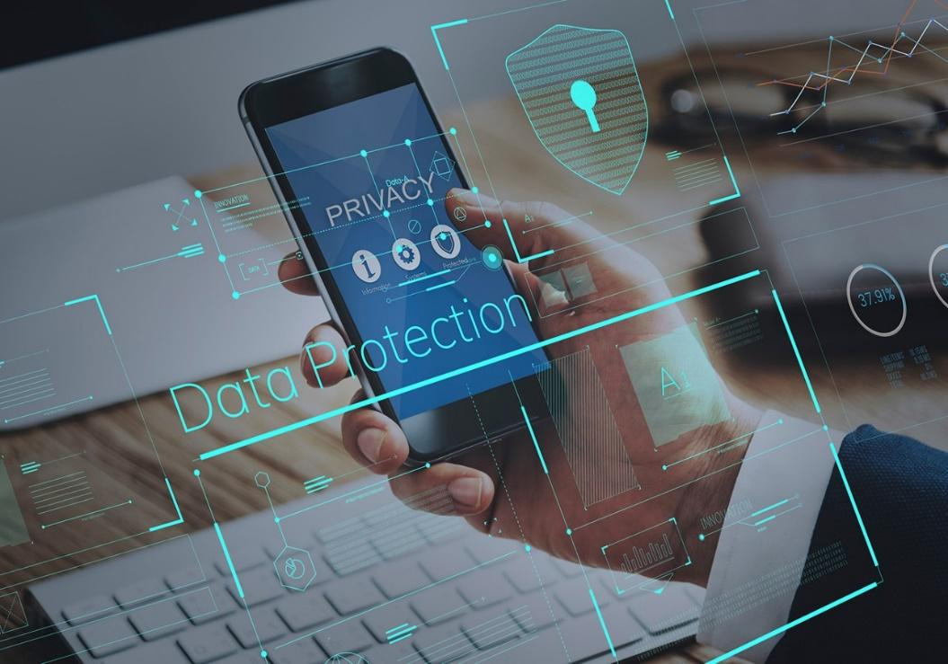
The rapidly changing technology and portability of mobile devices have forced people to heavily rely on those products. With their increased functionalities, mobile devices carry out a number of our day-to-day activities, such as surfing the web, booking appointments, setting up reminders, sharing files, instant messaging, video calling, and even mobile banking. Given all these functionalities, mobile devices are vulnerable to online threats and are also susceptible to physical attacks due to their portability. Some of the security threats include malware specifically designed for mobile devices i.e. worms and spyware, unauthorized access, phishing, and theft. But not all is lost. Here are some practical steps that will help you minimize the exposure of your mobile device to digital threats.
1. Use strong passwords/biometrics
Strong passwords coupled with biometric features, such as fingerprint authenticators, make unauthorized access nearly impossible. Your passwords should be eight or more characters long and contain alphanumeric characters. If your mobile device allows two-factor authentication, don’t hesitate to use it. You don’t want to be subject to unforeseen attacks. The complexities of your passwords in other apps might tempt you to store them in a similar way a browser does – that is, using the 'remember me feature.' This feature should be avoided at all costs since it only increases the chances of your password getting spoofed. Alternatively, if you lose your device, another person might gain full access to it. Furthermore, don’t forget to change your password from time to time (at least every three months).
2. Ensure public or free Wi-Fi is protected
Everybody loves free Wi-Fi, especially when the data plan is inexpensive. But cheap can turn expensive in a very devastating manner. That's because most of the free Wi-Fi points are not encrypted. These open networks allow malicious people to eavesdrop on the network traffic and easily get your passwords, usernames and other sensitive information. That threat isn't going anywhere anytime soon, either. To protect against Wi-Fi hacking, use applications that secure your connection or at least tell you the status of the Wi-Fi to which you are connected. WPA (Wi-Fi Protected Access) is more secure compared to WEP (Wired Equivalent Privacy). As a matter of being cautious, you should also turn off wireless connectivity (Wi-Fi and Bluetooth) when you are not using them. Not only will this help avoid automatic connection to unencrypted networks but also save your battery.
3. Utilize VPN
If you’re not sure about the security status of the network to which you’re connected, using VPN (Virtual Private Network) client is mandatory. A VPN will enable you to connect to a network securely. At the same time, any browsing activity you do on the public Wi-Fi will be shielded from prying eyes. It is also useful when accessing sites that are less secure. Non-HTTPS sites are visible to anyone who knows how to use networking and vulnerability tools. These sites are prone to MITM (Man-in-the-middle) attacks, which pave a way to eavesdropping and password sniffing. You really need to have a new mindset when it comes to fighting cybercrime.
4. Encrypt your device
Most mobile devices are bundled with a built-in encryption feature. Encryption is the process of making data unreadable. Decryption is converting the unreadable data into normal data. This is important in case of theft, and it prevents unauthorized access. You simply need to locate this feature on your mobile device and enter a password to encrypt your device. This process may take time depending on the size of your data. The bigger the data, the more time it will take. Most importantly, you need to remember the encryption password because it's required every time you want to use your mobile device. Also, as a fail-safe, consider backing up your data since some mobile devices will automatically erase everything if the wrong encryption password is entered incorrectly after a number of times.
5. Install an Antivirus application
The files you download and the apps you install on your mobile device might be packed with malicious code. Once launched, this code could send your data to hackers, thereby making you unsecured and robbing you of your privacy. To avoid that, installing a reputable antivirus application will guarantee your security. Some antivirus applications also offer more functionalities, such as erasing your data if you lose your mobile device, tracking and blocking unknown callers who might be a threat, and telling you which applications are not safe. In addition, they offer to clear your browsing history and delete cookies. Cookies are small software tokens that store your login information that might be leaked if someone malicious gets to them.
6. Update to the latest software
Your mobile device firmware might also be vulnerable to security threats. New loopholes might be exploited leaving your device open to threats, to avoid that, always update your firmware/device. Major mobile device firmware companies, such as Google Android and Apples iOS, roll out new updates from time to time. Most of those updates act as a security patch to known vulnerabilities on your device. You might set up updates to be manual or automatic.
Other things to consider
- Avoid turning on autofill – Some websites and applications will automatically fill in your username when you visit them. This is due to the autofill feature. Turn it off as soon as possible.
- Log out – After using mobile applications, especially those that are linked to one another, such as google applications, ensure that you log off each time you are done using them.
- Use only trusted stores – You should download apps from secure stores, such as Apple's App Store. This depends on the platform your mobile device uses.

Internal Assessment Criteria and Weight
- IAC0501The importance of safeguarding mobile and media devices is justified.
- IAC0502Mechanisms to safeguard mobile and media devices are discussed.

KM-01-KT06: Protecting computers, accounts and data as user
Topic elements to be covered include:
- KT0601Securing operating systems
- KT0602Internet security
- KT0603Securing email communications
- KT0604Securing the cloud
- KT0605Securing network connections
- KT0606Firewalls
- KT0607Antivirus programs
- KT0608Antispyware

KT0601 Securing operating systems
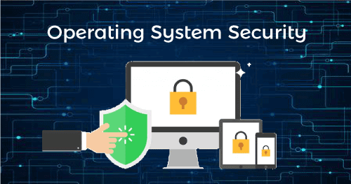
The term operating system (OS) security refers to practices and measures that can ensure the confidentiality, integrity, and availability (CIA) of operating systems.
The goal of OS security is to protect the OS from various threats, including malicious software such as worms, trojans and other viruses, misconfigurations, and remote intrusions.
OS security typically involves the implementation of control techniques that can protect your assets from unauthorized modification and deletion or theft.
The most common techniques used to protect operating systems include the use of antivirus software and other endpoint protection measures, regular OS patch updates, a firewall for monitoring network traffic, and enforcement of secure access through least privileges and user controls.
This is part of our series of articles about sandboxing.
What are Common OS Security Threats?
Here are a few of the most common threat vectors that can affect an operating system.
Malware
Malware is short for malicious software, which encompasses a range of attack vectors such as viruses, worms, trojans, and rootkits. Malware is injected into a system without the owner’s consent, or by masquerading as legitimate software, with the objective of stealing, destroying or corrupting data, or compromising the device.
Malware can also replicate, allowing it to spread further in a corporate network and beyond. Malware attacks often go undetected by the target user, allowing for the quiet extraction of sensitive data. In other cases attackers silently “herd” compromised devices into botnets and use them for criminal activities such as distributed denial of services (DDoS) attacks.
Denial of Service Attacks
A Denial of Service (DoS) attack is intended to clog a system with fake requests so it becomes overloaded, and eventually stops serving legitimate requests. Some DoS attacks, in addition to overwhelming a system’s resources, can cause damage to the underlying infrastructure.
Modern DoS attacks are waged by a distributed network of thousands or millions of bots (automated agents)—this is known as distributed denial of service (DDoS), and can be extremely difficult to mitigate due to its huge scale.
An example of a DoS attack is the repeated use of system requests in a tight loop, or a “syn flood” in which the attacker sends a large number of network requests, requiring the server to acknowledge each one, and exhausting its resources.
Network Intrusion
Network intrusion occurs when an individual gains access to a system for improper use. There are several types of network intrusion depending on the type of intruder:
- Careless insiders—authorized users who neglect to follow security policies or best practices, causing exposure of sensitive assets.
- Malicious insiders—authorized users who misuse their privileges for malicious indigence.
- Masqueraders—external individuals who pose as legitimate users, exploiting the account or credentials of an authorized user to gain access to the system.
- Clandestine users—attackers who penetrate the system by gaining supervisory control and going around access controls.
Buffer Overflow
The main function of a buffer is to temporarily store data. Each buffer has a capacity of data it can hold. During a buffer overflow attack, the buffer or other temporary data stores are overflowing with data. When the buffer overflows, the program attempting to write the data may overwrite other memory locations containing important information.
Threat actors look for buffer overflow vulnerabilities, which they can exploit to inject scripts that help them hijack the system or crash it.
How Can You Ensure Operating System Security?
Here are a few ways you can improve operating system security in your organization.
Authentication Measures
Authentication involves matching an identified user with the programs or data they are allowed to access. All operating systems have controls that can be used to verify that users who run a particular program are authorized to do so.
You can use the following techniques to authenticate users at the operating system level:

  - Security keys: keys are provided by a key generator, usually in the form of a physical dongle. The user must insert the key into a slot in the machine to log in.
  - Username-password combinations: The user enters a username that is registered with the OS, along with a matching password.
  - Biometric signatures: The user scans a physical attribute, such as a fingerprint or retina, to identify themselves.
- Multi-factor authentication: Modern authentication systems use multiple methods to identify a user, combining something the user knows (credentials), something they own (such as a mobile device), and/or a physical characteristic (biometrics).
Using One-Time Passwords
One-time passwords offer an additional layer of security when combined with standard authentication measures. Users must enter a unique password generated each time they log in to the system. A one-time password cannot be reused.
Examples of one-time passwords include:
- Network passwords: An application sends a one-time password to the users via a registered email address or mobile phone number. The user must enter this password to log in to the computer.
- Random numbers: The user receives a card with listing numbers that correspond to matching letters. The OS requires the user to enter the numbers that match a set of randomly generated letters.
- Secret keys: The user receives a device that generates secret keys. The user then enters the secret key into the OS system, which identifies the user credentials associated with the key.
Virtualization
Virtualization enables you to abstract software from hardware, effectively separating the two. The main advantage of virtualization is that it introduces a high level of efficiency and flexibility, while providing greater security coverage. There are many types of virtualization, including desktop, application, network, server, network, storage, and OS virtualization.
Operating system virtualization is a form of sandboxing. Learn more in our guide to sandboxing security.
What is OS virtualization?
OS virtualization enables you to multiple isolated user environments using the same OS kernel. The technology that creates and enables this type of isolation is called a “hypervisor”, which serves as a layer located between the device and the virtualized resources.
The hypervisor manages the virtual machines (VM) running on the device (typically 2-3 Vms). Each VM is used for each user or each security zone. There are several types of VMs that can run alongside each other. Here are the three main categories:
Fully locked-down VM
Should be used to provide access to sensitive data and corporate systems, such as IT environments, payment systems, and sensitive customer data.
Unlocked, open VM
Should be used to provide unrestricted access to non-corporate resources. For example, full web browsing sessions, installation of applications, and use of external devices.
Semi-locked-down VM
Should be used to provide access to standard corporate applications and resources, such as office documents, company email, and internal services.
Advantages of OS virtualization
Each type of VM is limited to the actions allowed by design. Any further action is restricted. This keeps the environment secure. The hypervisor runs below the OS of the device and splits the device into multiple VMs running locally with their own OS—effectively isolating users.
Because the users are isolated, the devices remain secure. This ensures that employees and third parties can gain access to company resources without endangering company resources.
Another major advantage of OS virtualization is that none of the virtualized environments can directly access the network. Instead, connectivity is enabled via an invisible, virtualized network layer that implements network segmentation directly on the endpoint device.
Testing and Validating Operating System Security
Securing an operating system or any software is an ongoing process that requires constant testing. Depending on the risk and priority of a system, security posture tests may take place on a monthly, weekly or daily basis. Here are a few testing methods you can use.
Vulnerability Assessment
Vulnerability assessment involves testing for weaknesses that may be lying undetected in an operating system. Identifying vulnerabilities allows you to identify possible vectors for an attack so you can better understand the risk to your system.
As part of a continuous process, vulnerability assessment attempts to stay on top of newly exposed vulnerabilities by locating, classifying and prioritizing them according to severity and impact. This process usually combines manual tasks with automated tools.
The following are some of the typical methods used for OS vulnerability assessment:
- Scanning for known vulnerabilities
- Scanning the software and applications on an operating system
- Scanning for malware
- Scanning for missing patches and updates
- Patch testing
- Port scanning

KT0602 Internet security
Internet security is a central aspect of cybersecurity, and it includes managing cyber threats and risks associated with the Internet, web browsers, web apps, websites and networks. The primary purpose of Internet security solutions is to protect users and corporate IT assets from attacks that travel over the Internet.
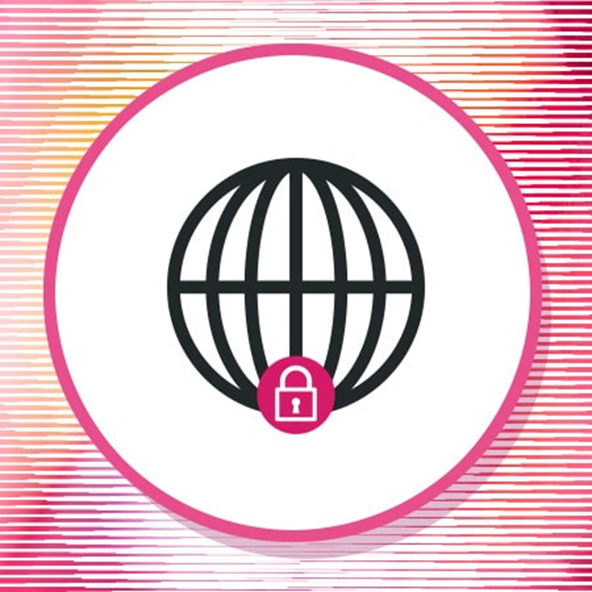
The Importance Of Internet Security
The COVID-19 pandemic drove a massive shift towards remote work, which changed where and how employees work and use digital resources. With widespread remote work, many employees are working from outside the enterprise network and its built-in cyber defenses, such as the corporate firewall.
As a result, remote workers are at an increased risk of being exposed to cyberattacks delivered over the Internet. Internet security solutions are needed to detect and block these threats before they can compromise employees’ computers and use them to gain access to corporate data or move laterally into the enterprise network.
Internet Security Threats
The Internet carries numerous types of risks for an organization. Some of the leading threats include:
- Malware: The Internet is one of the primary delivery mechanisms for malware, which can be embedded in malicious or compromised websites or attached to an email. Once malware has gained access to a system, it can encrypt or steal data, impair system functionality, hijack the infected system or take other actions to hurt an organization.
- Phishing: Phishing emails are a leading delivery mechanism for malware and a common form of social engineering used for data theft. This Internet-based attack vector is common and effective because it targets the person behind the computer, attempting to trick or coerce them into doing the attacker’s bidding.
- Data Loss: Data can be stolen from an organization over the Internet in various ways. Malware may collect or steal information; through human error, an employee may accidentally divulge it; or a user may send themselves or store sensitive enterprise and customer data within personal accounts (such as online storage and webmail accounts).
- Credential Compromise: Cybercriminals collect user credentials to gain access to corporate systems or log into online accounts. Credentials can be stolen via data breaches of user databases, collected via phishing sites or compromised through credential stuffing or through guessing weak and reused passwords.
- Malicious Websites: Many sites on the Internet are malicious or inappropriate for business use. Employees visiting these sites on corporate machines could be infected with malware, compromise their credentials, or access inappropriate or illegal content on company-owned systems.
Components Of Internet Security
Internet security solutions should provide comprehensive protection against Internet-borne cyber threats. Crucial capabilities include:
- URL Filtering: URL filtering solutions enable an organization to block users from visiting certain types of websites on company-owned machines. URL filtering can be used to block access to known-bad sites and to prevent employees from visiting sites with illegal or inappropriate content or ones that can negatively impact employee productivity (such as social media).
- Malicious Download Prevention: Malicious content can be downloaded from a website or attached to an email. An Internet security solution should detect and block malicious content en-route to the user’s device, before it enters the network or is downloaded to the user’s system, eliminating the threat to the organization. This typically involves a sandboxing solution.
- Anti-Bot Protection: If an employee’s computer is infected with a malware bot client, it may communicate with command and control (C2) servers or other bots controlled by an attacker. An internet security solution detects and blocks this malicious traffic.
- Data Loss Prevention: Employees may leak corporate data intentionally or inadvertently on malicious websites, via email, or through insecure cloud-based data storage. Internet security solutions should scan Internet traffic for sensitive and protected types of data and prevent them from being exposed outside of the organization.
- Phishing Protection: Phishing attacks are some of the most common cyberattacks and can have a significant impact on corporate cyber and data security. Internet security solutions should integrate email scanning and anti-phishing protections to identify and block suspected phishing emails from reaching the intended recipient’s inbox.
- Browser Exploit Prevention: Websites are able to run scripts within a user’s browser, which can exploit unpatched or zero-day browser vulnerabilities. Browser exploit prevention helps to detect and block the execution of this malicious code.
- Zero-Day Attack Prevention: Traditional, signature-based defenses protect against known exploits but are often blind to novel attacks. Zero-day attack prevention in an internet security solution detects and blocks novel attacks.

KT0603 Securing email communications
What Is Email Security?
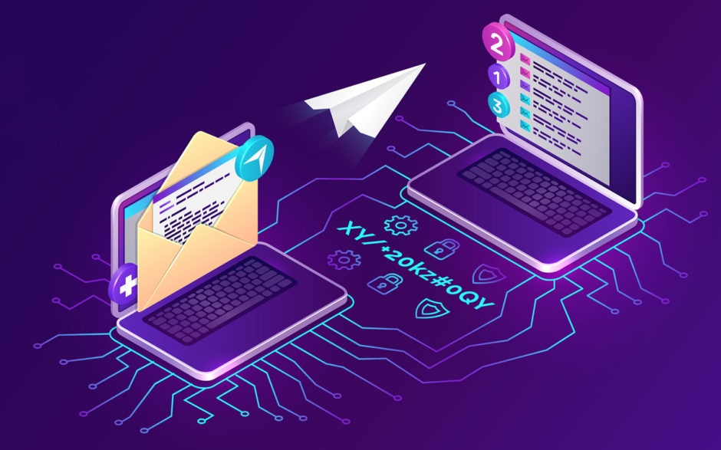
Email security can be defined as the use of various techniques to keep sensitive information in email communication and accounts secure. These precautions are taken chiefly against unauthorized access, loss, or compromise. It allows an individual or an organization to protect the overall access to one or more email addresses or accounts.

Email security safeguards the content of an email account or service that generally serves as a popular medium for the spread of malware, spam, and phishing attacks. This is usually done using deceptive messages to entice recipients to divulge sensitive information, open attachments, or click on hyperlinks that install malware on the victim’s device.
Stopping attacks at the entry point:

Email is also a common entry point for attackers looking to gain a foothold in an enterprise network and breach valuable business data. Hence, email security is necessary for both individual and business email accounts, and there are multiple measures organizations should take to enhance email security. Some of the proactive email security measures, from an end user’s standpoint, include:

- Strong passwords
- Password rotations
- Spam filters
- Desktop-based anti-virus or anti-spam application
Similarly, a service provider ensures email security by using strong passwords and access-control mechanisms on an email server. Here, the email messages are encrypted and digitally signed as they are placed in the inbox or are in transit to or from a subscriber’s email address.

The service provider also implements firewall and software-based spam filtering applications to restrict unsolicited, untrustworthy, and malicious email messages from being delivered to a user’s inbox.

Why Is Email Security Important?

Email is a popular attack vector. Therefore, enterprises and individuals must secure their email accounts against common attacks and attempt to gain unauthorized access to the communications’ accounts or content. Email security is significant due to the following plausible reasons:

Email is a common target for cyber-criminals

The first thing that employees get as soon as they join any firm is their official email account. The employees use their respective email IDs to access the company information and communicate with fellow employees daily. Every official communication to or from the company uses email as a medium.

Therefore, when employees work remotely, as observed in the COVID-19 pandemic situation, they tend to use their official emails for almost all communication. Such communications are vulnerable, and the employees are at the risk of being attacked by cyber-criminals. Cyber-criminals often use phishing, baits, social engineering, and many other types of attacks to exploit cracks in the security system.

A small loophole can affect the entire organization

A small loophole in an email’s security can allow deadly malware or spyware to sneak into the entire communication network, wreaking havoc in the entire organization. The situation worsens when the organization’s network is hit by deadly ransomware.

Even seasoned professionals and experienced employees fall victim to such tactics. These cyber thieves may also leak sensitive information by bringing it into the public domain or by selling it to bidders in the case of a personal vendetta.

Crucial for organizations to protect sensitive information

The company’s confidential information may include highly sensitive information that can be used against the organization or for criminal purposes. Cyber-criminals can also target day-to-day communication and change messages, which can create miscommunication and compel the communicators (the employees) to release or hide relevant information.

Such forgery may result in identity theft that can ultimately cause a breach of sensitive information. Both employees and organizations have to bear in mind that cyber-criminals only need a thin crack in security to jeopardize the entire workflow.

Below-average standard security measures

Although email service providers employ standard security measures, cyber-criminals can easily circumvent many of these measures. Generally, standard email defenses can only stop threats that are already known to them. In some situations, the email system also prompts its users to decide whether the received messages are secure or not and act accordingly. Advanced threat detection systems currently use artificial intelligence databases, real-time analysis, and machine learning for better protection.

However, such sophisticated advanced techniques are not employed under standard email security measures. That’s why it has become essential for users to use advanced security measures to identify a wide range of threats well in advance and stop them from entering the system.

Cyber-criminals use sophisticated & advanced methods

The technological advancement in online security systems can also empower cyber-criminals and hackers as they tend to use more and more advanced methods to breach various security firewalls.

These methods include AI fuzzing (AIF) and machine learning poisoning (MLP), enabling hackers to automate cyber-attacks. Besides, cyber-criminals can exploit many cloud vulnerabilities, damaging an organization’s workflow, business, image, and credibility in the industry.

All of these threats are grave enough for any organization, and hence it is crucial to install advanced email security measures. Organizations can also opt for security service providers who offer potent and improved email and overall online security.

KT0604 Securing the cloud
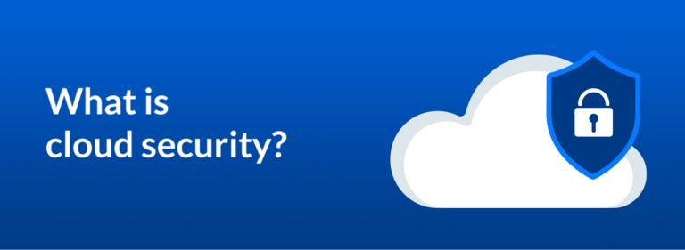
What is cloud security?
Preparing your business for future success starts with switching from on-premises hardware to the cloud for your computing needs. The cloud gives you access to more applications, improves data accessibility, helps your team collaborate more effectively, and provides easier content management. Some people may have reservations about switching to the cloud due to security concerns, but a reliable cloud service provider (CSP) can put your mind at ease and keep your data safe with highly secure cloud services.
Find out more about what cloud security is, the main types of cloud environments you'll need security for, the importance of cloud security, and its primary benefits.

Definition of cloud security
Cloud security, also known as cloud computing security, is a collection of security measures designed to protect cloud-based infrastructure, applications, and data. These measures ensure user and device authentication, data and resource access control, and data privacy protection. They also support regulatory data compliance. Cloud security is employed in cloud environments to protect a company's data from distributed denial of service (DDoS) attacks, malware, hackers, and unauthorized user access or use.

Types of cloud environments

When you're looking for cloud-based security, you'll find three main types of cloud environments to choose from. The top options on the market include public clouds, private clouds, and hybrid clouds. Each of these environments has different security concerns and benefits, so it's important to know the difference between them:

1. Public clouds
Public cloud services are hosted by third-party cloud service providers. A company doesn't have to set up anything to use the cloud, since the provider handles it all. Usually, clients can access a provider's web services via web browsers. Security features, such as access control, identity management, and authentication, are crucial to public clouds.

2. Private clouds
Private clouds are typically more secure than public clouds, as they're usually dedicated to a single group or user and rely on that group or user's firewall. The isolated nature of these clouds helps them stay secure from outside attacks since they're only accessible by one organization. However, they still face security challenges from some threats, such as social engineering and breaches. These clouds can also be difficult to scale as your company's needs expand.

3. Hybrid clouds
Hybrid clouds combine the scalability of public clouds with the greater control over resources that private clouds offer. These clouds connect multiple environments, such as a private cloud and a public cloud, that can scale more easily based on demand. Successful hybrid clouds allow users to access all their environments in a single integrated content management platform.

Why is cloud security important?
Cloud security is critical since most organizations are already using cloud computing in one form or another. This high rate of adoption of public cloud services is reflected in Gartner’s recent prediction that the worldwide market for public cloud services will grow 23.1% in 2021.
IT professionals remain concerned about moving more data and applications to the cloud due to security, governance, and compliance issues when their content is stored in the cloud. They worry that highly sensitive business information and intellectual property may be exposed through accidental leaks or due to increasingly sophisticated cyber threats.
A crucial component of cloud security is focused on protecting data and business content, such as customer orders, secret design documents, and financial records. Preventing leaks and data theft is critical for maintaining your customers’ trust and protecting the assets that contribute to your competitive advantage. Cloud security's ability to guard your data and assets makes it crucial to any company switching to the cloud.

KT0605 Securing network connections

Understanding home wireless network security
Knowing how to secure home WiFi networks is critical to protecting your devices from hackers and cybercriminals. If someone gains access to your local network, they can easily access your personal data by "listening" to your internet traffic.
Once this occurs, the cybercriminal can launch various attacks against your WiFi security, including “man in the middle” attacks, ransomware, or outright data theft.
The process of securing your home WiFi security system against these attacks is tedious at worst, and incredibly simple at best. But as cybersecurity becomes a bigger threat, it’s more important than ever to protect your network against cyberattacks.
How to protect your home network security
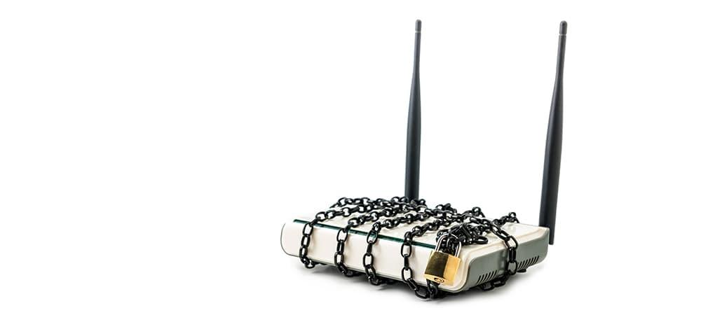
We compiled 10 of the best ways to increase the security of your home WiFi. And even if you can’t do them all, simply following several of these tips will help you lower the hacking risk that faces your WiFi-enabled devices and personal data.

Change the default name and password of your home network
The easiest thing you can do to secure your home internet connection is to change the default name. This name is also known as the SSID (Service Set Identifier), and you can alter it by following these steps:
- Open Windows Command Prompt
- Type in “ipconfig”
- Locate your IP Address
- Type your IP Address into your browser's address box
- Enter your router’s login credentials
- Open WiFi settings
- Change SSID and password
When changing your SSID and WiFi password, use a longer phrase that’s unique to that device. Don't use any obvious or personal information, such as your name or birthday, during this process.

Limit access to your wireless network
This may seem obvious, but avoid giving people you don’t know access to your home network. The more people who have your wireless network credentials, the higher the risk of your data falling into the wrong hands.
For example, if a contractor is in your home to perform repairs, they don’t need access to your home WiFi network. While there are exceptions to this rule – such as someone from your internet provider’s company – avoid allowing unknown devices to connect to your home network unless there is an important reason to do so.

Create a home guest network
Instead of giving out your wireless credentials to anyone who needs it, let them connect to a guest WiFi network. The guest networking option allows you to set up a separate WiFi network that provides internet access but hides any shared folders, printers, storage devices, and network devices connected to your primary wireless network.
Most wireless routers have this feature, which you can access via the device settings. When you set up the guest network, create a separate guest SSID and guest WiFi password.

Turn on wifi network encryption
Most WPA2 and WPA3 routers offer an encryption option. You can turn on this feature in your router’s WiFi settings, which you can access with your IP address and router login credentials. When you enable encryption for your WiFi network, it encrypts any data sent between your wireless channel and your device.
This will prevent anyone from eavesdropping on your WiFi network without logging into your WiFi network. Just remember that you’ll need to manually reconnect all of your devices to your wireless network after you enable this.

Turn on your router firewall
Most wireless routers are preloaded with excellent hardware-based firewall options. A good firewall helps to prevent unwanted traffic from entering or leaving your wireless network without your knowledge.
Router firewalls are often not turned on by default, which means you need to activate yours. To do so, log into your router settings using your IP address to enable the option. You may need to look under your router’s advanced settings to find the firewall toggle.
Using your router's firewall may slow down your internet speeds. As a workaround, you can turn off the firewall when you’re gaming or performing other tasks that require a faster connection. Once you’re done, just turn it back on.

Turn off your wifi network when you leave home
It may be too much of a hassle to turn off your WiFi network every time you walk out the door, but it’s important to disable your home wireless network if you leave for any extended period of time. This will guarantee that your network is completely safe.

Update your router's firmware
Your router’s firmware is an incredibly important piece of the secure network connection puzzle. Most wireless routers don’t auto-update their software, so you must do it manually.
To update your router's firmware, visit the manufacturer's website and download the firmware update file. Then, install it directly to your wireless router. Every router manufacturer has a slightly different process, so look for instructions on how to do it on their website.

Switch to a wpa3 router
WPA3 routers were first released in 2018, and they come with more robust security protocols to address many of the vulnerabilities found in WPA2 routers. If you rent your router from your ISP, chances are it may be a WPA2 device. In that case, you’ll have to purchase a separate WPA3 router.
While it may be an unplanned expense, a WPA3 router will enhance your home wireless network security. It will also likely increase the strength of your WiFi signal.

Disable remote access
Most routers have a remote access feature that allows you to access your WiFi network from anywhere you have an internet connection.
This may be a convenient way to manage your wireless network from another location, but it may also lead to network security issues. The potential for hacks only increases if you haven’t changed the default router credentials, which means anyone could access your wireless password and, as a result, your network.
Unless you absolutely must use the remote feature, it is best to turn it off. It’s simply too easy for hackers to potentially gain your legitimate credentials to access your wireless network. To disable this feature, look for the remote access settings in your router’s interface.

Place your router in the middle of your home
Most WiFi network signals are strong enough that someone outside of your home could “see” the connection on their device. To prevent this, you can simply move your router to a more central location in your home.
This is an easy, non-technical step to prevent unwanted access from someone sitting in a vehicle across the street from your home. As a bonus, it will provide better internet access in all areas of your home.
If you can’t move your router to a central area because of your home’s layout, you should at least move your wireless router away from windows. Windows don’t block the WiFi signal. Depending on the signal strength, it is possible someone could access your network from outside your property.

KT0606 Firewalls
Firewall defined
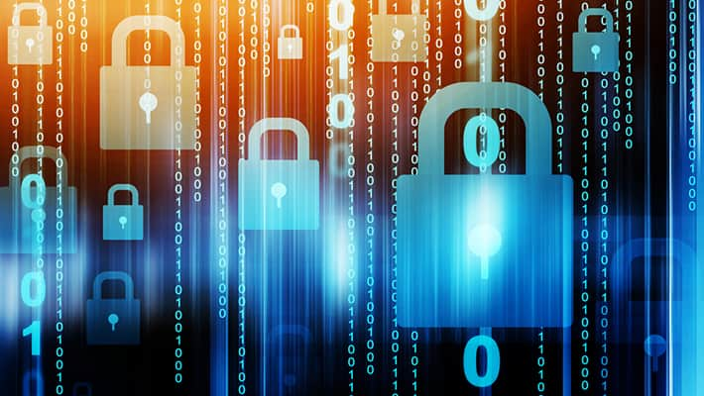
A firewall is a network security device that monitors incoming and outgoing network traffic and permits or blocks data packets based on a set of security rules. Its purpose is to establish a barrier between your internal network and incoming traffic from external sources (such as the internet) in order to block malicious traffic like viruses and hackers.
How does a firewall work?
Firewalls carefully analyze incoming traffic based on pre-established rules and filter traffic coming from unsecured or suspicious sources to prevent attacks. Firewalls guard traffic at a computer’s entry point, called ports, which is where information is exchanged with external devices. For example, “Source address 172.18.1.1 is allowed to reach destination 172.18.2.1 over port 22."
Think of IP addresses as houses, and port numbers as rooms within the house. Only trusted people (source addresses) are allowed to enter the house (destination address) at all—then it’s further filtered so that people within the house are only allowed to access certain rooms (destination ports), depending on if they're the owner, a child, or a guest. The owner is allowed to any room (any port), while children and guests are allowed into a certain set of rooms (specific ports).
Types of firewalls
Firewalls can either be software or hardware, though it’s best to have both. A software firewall is a program installed on each computer and regulates traffic through port numbers and applications, while a physical firewall is a piece of equipment installed between your network and gateway.

Packet-filtering firewalls, the most common type of firewall, examine packets and prohibit them from passing through if they don’t match an established security rule set. This type of firewall checks the packet’s source and destination IP addresses. If packets match those of an “allowed” rule on the firewall, then it is trusted to enter the network.
Packet-filtering firewalls are divided into two categories: stateful and stateless. Stateless firewalls examine packets independently of one another and lack context, making them easy targets for hackers. In contrast, stateful firewalls remember information about previously passed packets and are considered much more secure.
While packet-filtering firewalls can be effective, they ultimately provide very basic protection and can be very limited—for example, they can't determine if the contents of the request that's being sent will adversely affect the application it's reaching. If a malicious request that was allowed from a trusted source address would result in, say, the deletion of a database, the firewall would have no way of knowing that. Next-generation firewalls and proxy firewalls are more equipped to detect such threats.
Next-generation firewalls (NGFW) combine traditional firewall technology with additional functionality, such as encrypted traffic inspection, intrusion prevention systems, anti-virus, and more. Most notably, it includes deep packet inspection (DPI). While basic firewalls only look at packet headers, deep packet inspection examines the data within the packet itself, enabling users to more effectively identify, categorize, or stop packets with malicious data.
Proxy firewalls filter network traffic at the application level. Unlike basic firewalls, the proxy acts an intermediary between two end systems. The client must send a request to the firewall, where it is then evaluated against a set of security rules and then permitted or blocked. Most notably, proxy firewalls monitor traffic for layer 7 protocols such as HTTP and FTP, and use both stateful and deep packet inspection to detect malicious traffic.
Network address translation (NAT) firewalls allow multiple devices with independent network addresses to connect to the internet using a single IP address, keeping individual IP addresses hidden. As a result, attackers scanning a network for IP addresses can't capture specific details, providing greater security against attacks. NAT firewalls are similar to proxy firewalls in that they act as an intermediary between a group of computers and outside traffic.
Stateful multilayer inspection (SMLI) firewalls filter packets at the network, transport, and application layers, comparing them against known trusted packets. Like NGFW firewalls, SMLI also examine the entire packet and only allow them to pass if they pass each layer individually. These firewalls examine packets to determine the state of the communication (thus the name) to ensure all initiated communication is only taking place with trusted sources.

KT0607 Antivirus programs
Antivirus programs and computer protection software
Antivirus programs and computer protection software are designed to evaluate data such as web pages, files, software and applications to help find and eradicate malware as quickly as possible.
Most provide real-time protection, which can protect your devices from incoming threats; scan your entire computer regularly for known threats and provide automatic updates; and identify, block and delete malicious codes and software.
Because so many activities are now conducted online and new threats emerge continuously, it’s more important than ever to install a protective antivirus program. Fortunately, there are a number of excellent products on the market today to choose from.
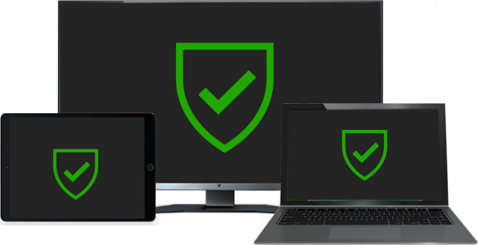
How does antivirus work?
Antivirus software begins operating by checking your computer programs and files against a database of known types of malware. Since new viruses are constantly created and distributed by hackers, it will also scan computers for the possibility of new or unknown type of malware threats.
Typically, most programs will use three different detection devices: specific detection, which identifies known malware; generic detection, which looks for known parts or types of malware or patterns that are related by a common codebase; and heuristic detection, which scans for unknown viruses by identifying known suspicious file structures. When the program finds a file that contains a virus, it will usually quarantine it and/or mark it for deletion, making it inaccessible and removing the risk to your device.

KT0608 Antispyware
Anti-spyware is a type of software that is designed to detect and remove unwanted spyware programs. Spyware is a type of malware that is installed on a computer without the user's knowledge in order to collect information about them. This can pose a security risk to the user, but more frequently spyware degrades system performance by taking up processing power, installing additional software, or redirecting users' browser activity.
Anti-spyware may also be called apyware on the Internet. Because "a" and "s" sit next to each other on the keyboard, many people accidentally type "apyware" when they try to search "spyware." Manufacturers and other interested parties capitalize on this by advertising "apyware."
Best Anti Spyware Removal Tools
- 1) TotalAV.
- 2) Outbyte PC Repair.
- 3) Advanced SystemCare.
- 4) System Mechanic.
- 5) AVG Free Antivirus.
- 6) Malwarebytes Adwcleaner.
- 7) Avast Free Antivirus.
- 8) Bitdefender Total Security.

Internal Assessment Criteria and Weight
- IAC0601Measures of protecting computers, accounts and data are identified.
- IAC0602The advantages of protecting computers, accounts and data are elaborated.

KM-01-KT07: Understand security incidents and reporting
Topic elements to be covered include:
- KT0701Data backup
- KT0702disaster recovery

KT0701 Data backup
Backing up data is critical to ensuring system integrity, but if done incorrectly, it can exacerbate already-existing security issues. Fortunately, there are a number of best practices that can be followed.
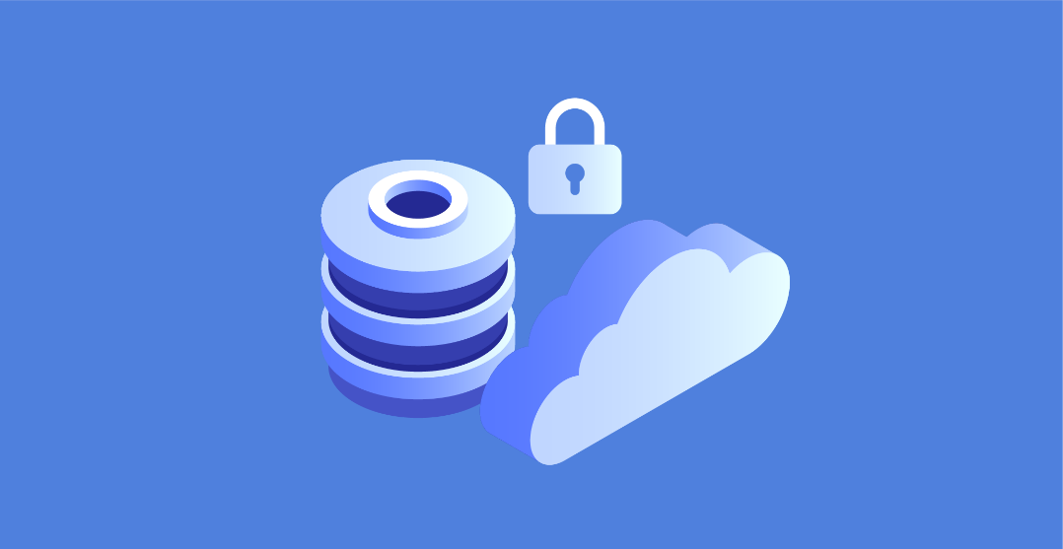
In order to keep your data safe and secure, you need to have regular data backups. However, these backups are often the source of many security problems. In fact, a large number of security breaches can be traced back to the mismanagement of data backups. A lack of adequate data backup controls is evident in the headlines and security surveys that are published. There's nothing wrong with using best practices when developing an enterprise data backup strategy.
Millions of sensitive business records have been compromised in backup-related mistakes over the last few years, according to recent reports. Indeed, these are just the incidents that have been publicly reported. Confidential information, including intellectual property, is no less vulnerable to data backup-related breaches than other types of sensitive data. Without a solid back-up plan in place when things go wrong, security is the first thing on the shark’s menu.
As long as there is a process for replicating sensitive data, many storage professionals believe that their organization is safe. However, this is only half of the battle. A new set of dangers arises from what can be done with data backups, which are often overlooked. Because of this, it is essential to incorporate secure data backup guidelines into the overall enterprise information security strategy.
Here are 10 ways to keep your data backups safe and secure from threats like ransomware, malicious insiders, and external hackers, both locally and in the cloud:
Make sure you have a backup plan in place
It is important to make sure your security policies include backup systems. Access control, system monitoring, and malware protection all have a direct impact on data backups.
Incorporate backup systems into your disaster recovery plan
Your disaster recovery and incident response plans should include a backup of your computer files and other important information. A ransomware outbreak, an employee break-in, or an environmental event such as a flood or hurricane can all compromise or destroy a company's data backups. If you don't have a plan in place for what to do if and when the time comes, your backups could be harmed.
In order to protect data backups, restrict access to them
Only those who need to be involved in the backup process should be given access rights. Software and data backups are no exception here either. Systems that provide backup access, whether on-premises or in the cloud, should not be undervalued.
Consider a variety of backup options
Keep your backups in a different location, such as a different building. Your data centre and your backups could be wiped out in one fell swoop if a natural disaster, a fire, or some other rare, but impactful, incident occurs.
Protect data backups from unauthorized access
Backing up to NAS, external hard drives, or tapes is fine as long as access to those locations can be tightly controlled. Your backup files are just as important as your computer's hard drive. SOC audit reports, independent security assessments, or your own investigations may be able to confirm this.
Ensure the safety of all backup media devices
Some backups are still kept on portable drives, tapes, and other media, despite the widespread use of hard disks and solid-state drives. Fireproof and media-rated safes should be used in these situations. One of the most common places to keep backups is in a “fireproof,” but paper-only safe. A standard fireproof safe only serves to provide a false sense of security for backup media such as tapes, optical disks, and magnetic drives, which have lower burning/melting points than paper.
Check out the security measures in place for your vendors
Find out what security measures your data centre, cloud, and courier service providers are using to keep backups safe. Despite the fact that lawyers appreciate well-drafted contracts, they are not always sufficient. As a fallback measure, contracts can help protect sensitive data, but they won't stop it from being exposed in the first place. Check to see if security measures are in place as part of vendor management initiatives.
Ensure the security of your network
Backups should be stored on a separate file system or cloud storage service that is located on a separate network. Ransomware-related risks can be minimized by using unique login credentials that are not part of the enterprise directory service. The use of two-factor authentication can increase the security of your backup system.
Encrypt backups as a top priority
Whenever possible, encrypt your backups. The same is true for backup media and files, which must be encrypted with strong passphrases or other centrally managed encryption technology if they are to be taken outside the premises at any point in time. Encryption is an excellent final layer of defence when implemented and managed correctly. It's reassuring to know that even if your backups are corrupted or destroyed, you won't be able to access them. This is especially useful when it comes to meeting compliance and notification requirements in the event of a data breach.
Ensure that all of your data is backed up and tested frequently
These data backup flaws are likely to exist within your business. Before you're hit by a ransomware attack or data destruction, it's a good idea to find out where your vulnerabilities lie. Hire an unbiased third party to find the holes in your data backup processes and systems on a regular basis or look for them yourself. In the end, it's the little issues that aren't so obvious at first that can be the most difficult to deal with.

KT0702 Disaster recovery
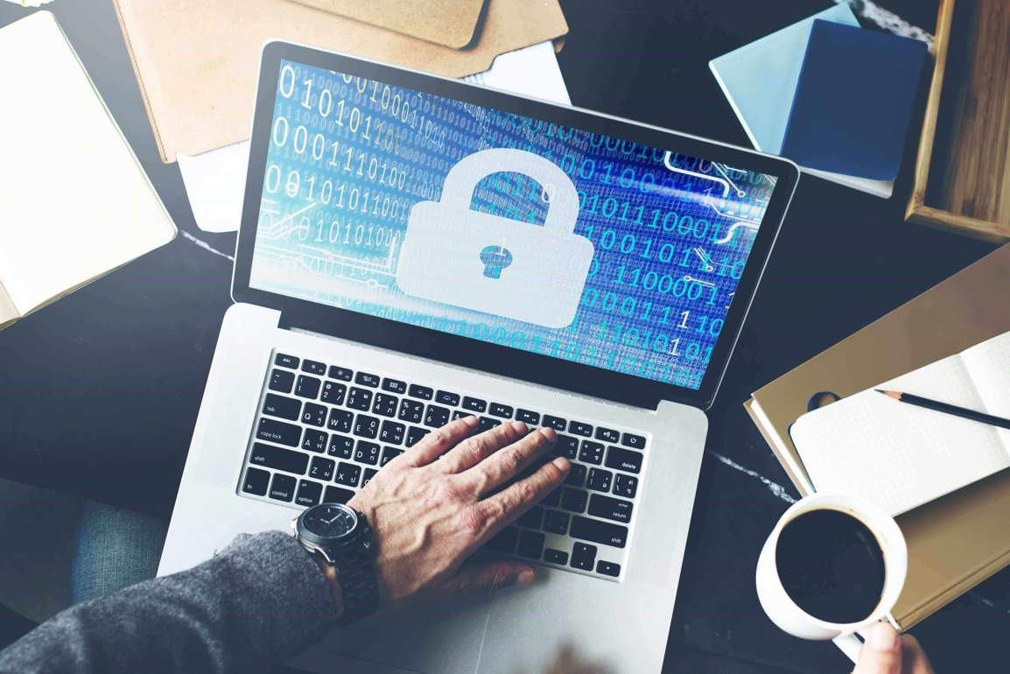
Security breaches and cybercrimes are becoming ever more sophisticated, which turns data protection strategy into a key factor for your business survival. Unexpected hardware failures can render your services unavailable to users and become a true disaster if you don’t have a comprehensive data protection solution in place. Even a simple human error such as unintentional modification or deletion of data may totally disrupt your daily operations. Whatever happens, your ability to quickly handle an emergency situation can help you reduce downtime and thus minimize damage, both financial and reputational. This is exactly why having a carefully developed incident response and disaster recovery plan is so important.

What Is Incident Response?
Incident response can be defined as a set of measures you may take to cope with various kinds of security breaches. Also referred to as IT incidents and security incidents, such events are to be handled in a way to reduce recovery time and costs. To mitigate risks and be prepared for as wide a range of events as possible, you need a detailed and comprehensive incident response plan. This is a set of procedures and actions to be taken when a security breach is revealed. An incident response specialist is supposed to ensure a uniform approach and make certain that none of the outlined steps are skipped. Another important task is to determine where the problem comes from in order to prevent similar incidents in the future. Finally, it is important to regularly update the incident response plan to make sure it addresses both the ever-evolving cyber threats and current needs of your infrastructure.
Types of Security Threats
One of the key principles of incident response and disaster recovery is to carefully develop a plan of actions to cover as many recovery scenarios as possible. Naturally, the key point is to do this before a disaster strikes and such a plan is urgently required. To begin with, you need to take an attentive look at the types of security incidents. Some of the most common ones are as follows:
- DDoS attack
The aim of a distributed denial-of-service (DDoS) attack is to disrupt services and traffic of a target server, network, or website. To carry out an attack, one needs a network of computers infected with malware, or a botnet. The attacker controls bots remotely and sends them the necessary instructions. During a DDoS attack, machines in a botnet start sending simultaneous requests to the target. The flood of malicious traffic can potentially slow down or completely crash the target system. If successful, a DDoS attack renders the service unavailable to users and often results in significant financial damage, as well as the loss or theft of sensitive data.
- Malware and ransomware
Malware is a broad term that refers to viruses, worms, spyware, and other types of malicious programs. In some cases, it can act in a relatively inoffensive way (change screen background or delete files), but sometimes it remains hidden and steals sensitive information. Ransomware is a subset of malware, and the key difference is that the system’s user receives a notification with a demand to pay a ransom. As an example, the victim may find their disks or files encrypted, while the attacker normally promises to restore the machine to its previous state after they receive the payment.

Cybersecurity professionals insist that companies should never pay in such cases. On our part, we emphasize that an adequate backup solution is an effective weapon against ransomware. After all, the main reason why a victim might pay a ransom is because they don’t have an alternative.
- Phishing
This is a form of cyber fraud with its purpose being to access personally identifiable information (PII). As a rule, attackers use social engineering techniques. The victim might receive an email or text, or come across a social media post containing a link to a page where the visitors are asked to submit their personal details. The key idea is to make the victim believe that they are dealing with a reputable entity like a bank, government agency, or legitimate organization. Incident response in the event of a phishing attack should include both preparation and post-incident phases. It is also important to educate your colleagues so that they can recognize the signs of a phishing attempt and avoid putting your network at risk.
- Insider threat
Security threats of this type come from people related to the workflow of an organization, such as its employees, former employees, third parties, contractors, business associates, and so on. In most cases, their main motivation factor is personal gain. However, sometimes malicious insiders want to harm an organization and disrupt its services out of revenge.
A common scenario is when data is stolen on behalf of external parties, such as competitors or business partners. Careless workers who mishandle data or install unauthorized apps pose a threat as well. In other words, you are to carefully analyze all the possible attack vectors to design comprehensive incident response and disaster recovery plans. Once again, training your employees and implementing a set of security procedures are two important steps which can help protect your corporate network.
Incident Response Plan vs. Disaster Recovery Plan: What Is the Difference?
Put simply, an incident response plan should be incorporated into a disaster recovery plan. These are two components of a comprehensively developed data protection strategy. A common mistake is to create these two plans independently. The right practice is to develop, deploy, and test them as a complex of measures to protect data security and integrity. At the same time, even though the objectives of incident response and disaster recovery plans are related, they are not the same.
The key difference between incident response and disaster recovery plans lies in the type of events they address. As explained above, an incident response plan refers to the scope of actions to be taken during an incident. It defines an incident response team’s roles and responsibilities to ensure smooth running of incident response processes. In turn, a disaster recovery plan focuses on bringing your production environment back to an operational state after an incident occurs and successfully recovering from any caused damage.
A noteworthy thing is that security vulnerabilities, human errors, and technological malfunctions are possible to avoid, which is why we once again emphasize the importance of employee training. Apart from this, analyze the needs of your environment and make sure that your plans meet them. Consider preparing a plan tailored for the possible failure of a VM, network, cloud, data center, and so on. As an example, an effective data protection solution could save you quite a lot of time and costs. Apart from this, there is a risk of a disaster affecting your physical server, office, an entire building, or even a region. Even though some of these scenarios may seem unlikely, it is better to be prepared for as wide a range of unexpected events as possible.
In this way, the purpose of both incident response and disaster recovery plans is to minimize the impact of an unexpected event, recover from it, and return to the normal production level as fast as possible. Also, both of them contain an element of learning: it is important to identify the roots of a problem and, in such a way, decide how to prevent similar incidents in future. The principal difference is their primary objectives. The purpose of an incident response plan is to protect sensitive data during a security breach, while a disaster recovery plan serves to ensure continuity of business processes after a service disruption. A good practice is to document two plans separately. This will simplify the process of document creation, as well as let you find an appropriate action scope faster, both during testing and in a real-life situation.

Internal Assessment Criteria and Weight
- IAC0701The effect of security incidents is explained

References
https://www.cisco.com › Products & Services › Security
https://www.techtarget.com › searchsecurity › definition
https://www.itgovernance.co.uk › what-is-cybersecurity
https://www.gartner.com › topics › cybersecurity
https://www.ibm.com › za-en › topics › mobile-security
https://www.archonsecure.com › mobile-device-guide

